Olvin among world’s top start-ups helping retailers rebuild from Covid
The second annual Discovery report, published today by RWRC, celebrates 40 global start-ups powering retail innovation at a time when it is needed most, including cutting-edge solutions being used by Tesco, Nespresso, AO.com, M&S and more
- Featuring solutions from supply chain and store innovations to personalisation, AI, data and marketing, the 40 start-ups are enabling retailers to adapt their businesses and lean in to disruption
- Start-ups launched on, or after, January 1, 2014, and have worked with retailers either through a pilot or full-scale solution to help them transform their businesses
- The start-ups are supporting over 30 retailers and brands including Tesco, M&S, Nespresso, KFC, Carrefour, Samsung, Depop, and John Lewis Partners

Olvin has been named among the top 40 retail tech start-ups operating globally in Retail Week World Retail Congress’ (RWRC) second annual Discovery report, published today.

Olvin’s platform is unique for many reasons, but it excels in understanding the changing physical world. By accessing the right insights for retailers and combining this with curated data sets, our platform Almanac delivers smart and complex insights that are easy to understand.
Leveraging trillions of data points, Almanac’s neural network architecture is able to bring predictive insights to brands and retailers on consumer traffic and trends in the same way that e-commerce retailers have had for years.
Physical retailers, product owners, and businesses need these insights to thrive in the post-pandemic world and with Almanac, it provides the tools for businesses to grow their revenue, increase customer loyalty and maximize their working capital.

Olvin’s founder and CEO Sam Amrani said, “We are very excited to be included in such a prestigious report, and it’s great to see that the industry is recognizing the huge potential that AI can have on a brick and mortar retail, particularly in enhancing the level of understanding businesses can get on their customers .”

He added, “This is an excellent opportunity for us to show how AI can help retailers get back on track after the pandemic, and it shows how predictive intelligence can benefit the smallest of retailers right through to larger brands and establishments. “

Most retailers know they need to work with tech start-ups to give them a competitive edge - it is understanding which firms are going to truly add value that is the challenge. Judged by a panel of retail and start-up experts*, the Discovery report tells retailers all they need to know.

Virtual try-on assistants, vertical farming, ‘save now, buy later’ payments, in-store marketing robots and bookable shop space are just a handful of fresh-thinking players featured.

And it is this fresh thinking that is required if retailers and brands are to remain competitive and balance bottom lines with customer expectations as disruption from the pandemic persists.

Drawing on case studies from Discovery, the ROI from retailer-start-up partnerships is clear:

- M&S has trialed a partnership with instant virtual try-on start-up Texel to drive purchasing intent; customers that use the tool are five times more likely to purchase and 30% less likely to return items
- Samsung has benefited from a 20% increase in basket revenue and 28% uplift in items per basket from working with AI-powered product bundling start-up Increasingly
- Carrefour UAE is using Simbe Robotics’ inventory robots Tally to monitor all-important inventory availability and has now expanded this to 12 of its stores
- Lidl has used ParcelLab’s automated personalised shipping message service to engage 85% of customers receiving shopping emails to return to its website

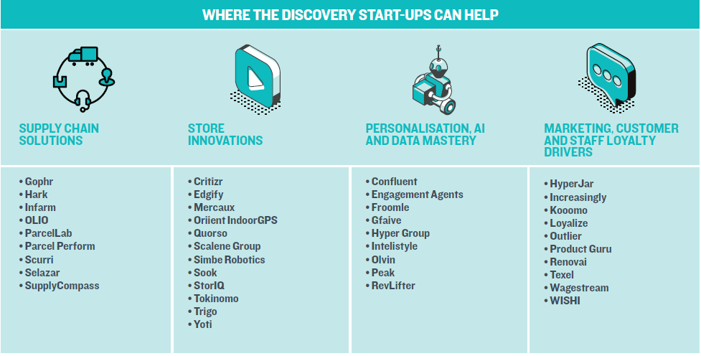

Featuring solutions from supply chain and store innovations to personalisation, AI, data and marketing, the report looks at how retailers have benefited from adapting their businesses - and their thinking - to lean into a whole new set of disruptions, trends and challenges.

The start-ups operate across all parts of the world, from Europe and the US to Singapore and Israel, and have worked with more than 30 retailers and brands including Tesco, M&S, Nespresso, KFC, Carrefour, Samsung, Depop, AO.com and John Lewis Partners.

Ian Shepherd has been one of the Discovery judges for the past two years. Shepherd is non-executive director at Bensons for Beds, former CEO at retailer Game, author of The Average is Always Wrong and runs the consultancy Moving Tribes where he advises retailers, digital start-ups and consumer businesses.

Shepherd commented: “This year’s Discovery cohort – just like last year’s – are going to be critical to the future of our sector.

“A different retail sector is possible, a million miles from the old world of ‘how many stores are you going to open?’ and ‘what was your like-for-like last quarter?’ – a retail sector that marries the instinctive customer understanding any good retailer has with the innovation and laser-like focus that new technology allows.”

-------------------------------------------------------ENDS -----------------------------------------------------------
Notes to editors:
Access the Discovery report in full here. Please use this link when promoting the Discovery report.
The tech start-ups featured in Discovery started trading on, or after, January 1, 2014, and have worked with retailers and brands on a pilot or full scale solution to help them transform their business.
*The judging panel included Co:Cubed chief executive Jeremy Basset, Founders Factory managing director - retail and beauty, Isabela Chick, Bensons for Beds non-executive director, former Game CEO, and author of The Average is Always Wrong Ian Shepherd, NBK Retail founder and retail analyst Natalie Berg, Retail Economics chief executive Richard Lim, research director, consultant and author Miya Knights, Retail Week head of content Grace Bowden, Retail Week head of insight Lisa Byfield-Green, and Retail Week commercial content editor and former Startups.co.uk projects editor Negan Dunsby.
Entries were submitted from October 2020 to January 2021 with the shortlist decided by Retail Week’s editorial team and the Discovery judging panel. Information about each start-up was correct at the time of entry.
For more information on Discovery and the start-ups featured, please contact Megan Dunsby – megan.dunsby@retail-week.com
Olvin is an AI-powered solution focused on predicting consumer behavior. On a daily basis, Olvin crunches billions of real-world data points from location and demographic through to weather and events in a powerful yet easy to use platform - Almanac. This enables businesses of all sizes to gain a deeper understanding of their shoppers in the real-world. Its award-winning platform, Almanac, leverages powerful AI + ML to predict consumer behavior. This is made accessible in our easy-to-use platform that informs predictive seasonality, identifies rends in a direct and actionable way and gets a snapshot of the competitive landscape. We believe physical retailers, brands and chains can utilize Almanac to thrive in the post-pandemic world by helping them to save costs, grow revenue and increase loyalty. "Its novel approach to insight and analytics gives all retailers, regardless of size or scale an ability to affordable and actionable insight with its platform offering disruptive pricing, starting at just $249 per month.
For further information on Olvin, please contact Elliott Poulter – elliott@olvin.com

