

# kubik Named Best Agency for Creativity and Key Differentiators

The *kubik* team takes great pride in being named the top agency for **Creativity and Key Differentiators** by EXHIBITOR magazine in their [2021 Find It Top 40](https://www.exhibitoronline.com/news/article.asp?ID=21475).

Agencies considered for this award were evaluated by industry experts on the following attributes:

* The value derived by their clients.
* The uniqueness of their positioning strategy.
* A critical review of recent past projects for engagement intent and appeal.
* The ability to stand out from their competitors.

The Creativity and Key Differentiators award recognizes the greatest diversity in capabilities, award-winning design and overall excellence. Established in 1983, *kubik* specializes in creating physical and digital omni-channel experiences that help build human connections and excitement.

We immerse ourselves in every brand we work with, infusing nearly four decades of experience into every step of the process. From pre to post, and everything in-between, *kubik* is an indispensable partner that makes experiential platforms come to life.

We are grateful to be singled out among the many agencies who were considered for this award. Our global *kubik* team works tirelessly on behalf of our clients, and we take great pride in helping them shine and connect with their audiences… and that’s what it’s all about!

When [speaking of the agencies being considered](https://www.exhibitoronline.com/news/article.asp?ID=21475&utm_source=MarkA&utm_medium=email&utm_campaign=5287&utm_term=ta&utm_content=F) for the 2021 Find It – Top 40 awards, Travis Stanton, editor of EXHIBITOR magazine, stated that “the competition for a spot on the 2021 Find It – Top 40 list was extremely competitive, especially given the challenges exhibit houses faced over the course of the past year.”

**A Few Experiential Projects That Strut Our Stuff**

[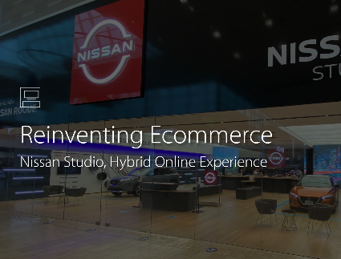](https://thinkubik.com/project/nissan_re-inventing_e-commerce/)[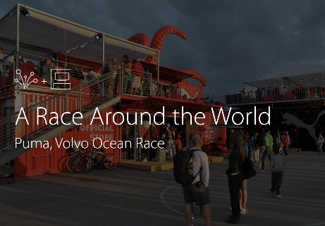](https://thinkubik.com/project/a-race-around-the-world/)[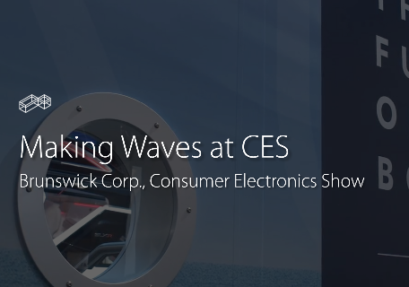](https://thinkubik.com/project/brunswick-corp/)Some of the eye-popping experiences we have created for our clients. [Take a look here](https://thinkubik.com/work/)!

## A Little Bit About kubik

At kubik, we create brand experiences.

From ideation to industry research, project management, engineering and fabrication, logistics planning, content creation and software development, data capture, analytics, and IT support, kubik provides all the strategic development, planning, creative, building and execution capabilities our clients need to make ***omni-channel experiential*** marketing come alive.

We are a strategic partner for some of the world’s best-known brands and support them in their endeavours to create face-to-face and online customer experiences of all types.

With highly skilled teams across North America, Europe, and Asia, *kubik* can help create your next experiential platform!

Learn more [about us here](https://thinkubik.com/about/).

**About EXHIBITOR Magazine**

[EXHIBITOR magazine](https://www.exhibitoronline.com/index.asp) is an award-winning industry-leading resource for trade show and corporate event marketing education, news, and resources.



1680 Mattawa Avenue, Mississauga ON, L4X 3A5

 North America toll-free: 1-877-252-2818

 Europe: +31.20.581.3030

[info@thinkubik.com](mailto:info@thinkubik.com)

_____________________________________________________________________________________

Founded in Toronto, Ontario Canada in 1983 by Sam and Elliot Kohn, kubik got its start by building exhibition displays. Recognized for their excellent quality and creativity, began working with well-known brands such as Disney, Nike, and Volkswagen, expanding further into experiential marketing and storytelling. Today, kubik is a multinational agency with offices across North America, Europe, and Asia, while remaining a family-run business. We build engaging, omni channel experiences and meaningful connections between brands and people.