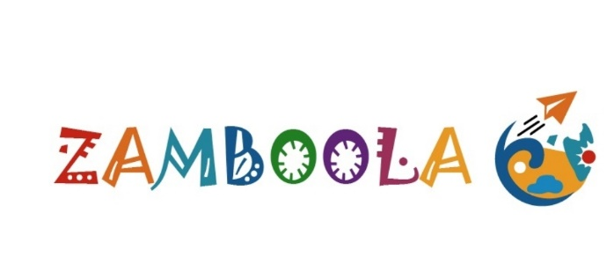
The Region’s first ‘local experience platform’ Zamboola.com goes live
Book Now Pay Later model for up to 10,000 AED ($2722) at no extra charge to redefine domestic tourism.
May 11th, 2021 – Dubai, UAE
Zamboola.com a new ‘local experience’ operator has gone live. With its unique and the region’s first “Book Now Pay Later” feature - residents, expats, nationals from the UAE and Saudi Arabia (KSA) can explore like never before.
Users can book popular local experiences for up to 4,000 and 10,000 AED ($2722) for custom experiences and pay in up to 4 equal parts, spread over 4 months - at no extra cost, no interest, no credit reports, no deposits on any debit or credit card issued here.
The launch of Zamboola comes close on the heels as the UAE tourism sector was among the least affected and fastest to recover globally. It performed well in 2020 despite the COVID-19 according to the Ministry of Economy and industry data.
“Travel is not just for tourists. For a resident, family, friends, team events, party, or wedding they are a great way to rejuvenate, destress, and celebrate. Zamboola was created for this new normal,” says Madhan Saminathan, the Founder and CEO.
The UAE recorded a 54.7% hotel occupancy in 2020 – the world’s second highest (after China) while the global rate dropped to 37% due to the pandemic.
Staycations and domestic tourism were the UAE’s silver lining as they are cost-effective, simple, with no visa hassles, potential flight issues, delays, quarantine vs. overseas trips.
It is no surprise, in 2020 the UAE’s domestic travel spending was AED 41 billion and officially ‘the year of the staycation’. A new campaign underway is set to soar this to AED 80 billion over the next few years.
“From desert safaris, theme parks, adventure, snow to sandy beaches, modern to the historic, deserts to tropical rainforests, indoors or outdoors, 7 to 70-year-old – UAE has got it all. In fact, many residents have not explored a lot of attractions or unaware. It could be for Eid, weekend getaway, day trip, short holiday, retreat, special occasion or party - Zamboola has all the options,” says Madhan.

“Domestic tourism surged 107% despite the Covid19 crisis because of the Government’s proactive approach, residents following all precautions, vaccination and operators being compliant,” he adds. “Zamboola was created, so customers can enjoy safely without strain on their wallet or mind. “
All Zamboola.com experiences are safety verified, with trained staff, and working with trusted venues and partners.
With special offers, unique payment option its affordable luxury for everyone. If it is not available, Zamboola can create custom local experiences for up to 10,000 AED payable over up to 4 months at no extra cost.
The site’s e-commerce platform is built with the latest technology, fast, secure, multi-lingual with a seamless booking and support.
As part of its expansion Zamboola is soon opening a new marketplace for niche, specialist, unique experience operators and guides to list for free and leverage Zamboola’s platform to grow their business.
High-res Image: https://www.dropbox.com/t/DLfXkurZv6sGuPw4
Caption: Zamboola.com the region’s first ‘local experience’ provider to book local experiences for up to 10,000 AED and pay later over 4 months at no extra cost.
About Zamboola:
Over the past 15 years, TripKonnect (the parent company) has served tens and thousands of travelers from all over. Zamboola.com its new brand is a ‘local experience operator’ with a unique ‘Book Now Pay Later’ model that combines AI, security, and service. It was founded by Mr. Madhan Saminathan a 15-year veteran with extensive travel and hotel management experience.

For more information, photos, interviews, or quotes, contact:
MarComm Team
Mobile: +971 58 129 2628 (WhatsApp only)
Online: www.zamboola.com
Email: hello@zamboola.com

*End. Page 2 of 2

