Press Release
Cogito Tech Acquires SOC 2 Type II Certification Fortifying Itself into the Data's Safest Haven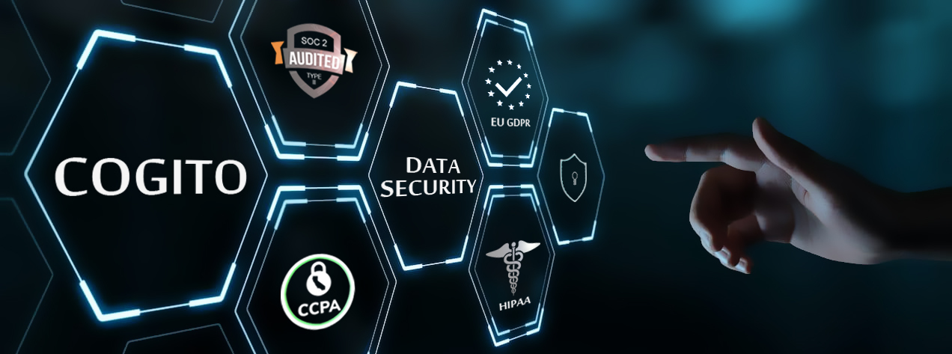
Date: 22nd April 2021
Contributor: Nitika Joseph
Media Contact:
Nitika Joseph
Content Manager
+91-9911595768
nitika.joseph@cogitotech.in
Domain: Data for AI & ML, Data Processing, Data Privacy and Security, SOC 2 TYPE II, HIPAA, GDPR, CCPA Compliance, Secure Delivery Center, Computer Vision, NLP, Content Moderation, Data Processing Services.

Levittown, NY. Cogito Tech LLC goes a step further to be SOC2 Type II certified center for processing your data and adhere to the international standards of Data security.
Rohan Agarwal, CEO of Cogito, humbly admits that the time-taking process of achieving SOC 2 TYPE 2, & adding up to their other certification namely, HIPAA, GDPR, and CCPA, have made them the first choice for many. It becomes a prominent reason why new and old clients seeking data-related services are attracted to Cogito. This credibility has added Cogito to be the most reliable and secure delivery center to process sensitive and confidential data for AI or ML with customized workforce solutions and workflow strategies. By not limiting itself to be the first choice for a specific country, but its entrustment goes beyond the borders.

Mr. Rohan shares his views about what makes their company worthy of trust for different AI start-ups and the key reason for them to be the leaders in the field, “Being a data processing company, its crucial to work with confidential and extensively classified data appropriately. A lot of our business partners are large enterprises, academic institutes, research organizations, or AI start-ups. They are all building next-generation AI technologies, which are high in priority and extremely susceptible. Thus, our clients need to have the peace of mind that their data is being processed in a highly secure, supervised, and controlled environment. To give them this mental peace, we have invested heavily in keeping the appropriate kind of security protocols and controls in place.”

The investment that Mr. Rohan is talking about is reflected in Cogito’s remarkable achievement of SOC 2 TYPE II along with HIPAA, GDPR, and CCPA compliance certifications. Which is crucial to international data privacy and security standards, these certifications speak for themselves. Let us find out their significance:

In the year 2021, Cogito successfully achieved SOC 2 Type 2 certification. The term SOC-System and Organization Controls, refers to the series of measures pertaining to global standards designed and designated to certify how a given service organization conducts and regulates its information. The goal remains to provide confidence and assurance standards to organizations, when they engage with third-party vendors.

Specifically, SOC 2 Type II reports are built on the financial reporting basis of SOC 1 and require Standard Operating Procedures (SOP) for organizational oversight, vendor management, risk management, and regulatory oversight. Cogito by accomplishing this is now a certified service organization, appropriate for businesses requiring documented standards and dealing with highly advanced I.T. service providers. It also includes the framework of five key sections, forming a set of criteria called the Trust Services Principles, which are:
- System security
- Processing system integrity
- System availability
- Privacy of personal information that the service provider collects, retains, uses, chooses to disclose, and disposes off for user entities, and
- Confidentiality of the information.
Type II reports at Cogito were formed after rigorously evaluating systems for over a specified period (minimum of six months). The ultimate certification of SOC 2 Type II is one of the most comprehensive certifications within the Systems and Organization Controls protocol. Businesses seeking a vendor, like I.T. services providers, will find this to be the most useful certification when considering a possible service provider’s credentials.

Cogito by achieving this certification has proven that its system is designed to keep its clients’ sensitive data 100% secure. When it comes to working with cloud and other related I.T. services, Cogito is wear the armor of high performance and certified reliability, essential and increasingly required by regulators, examiners, and auditors in the market.

Apart from this Cogito also bears three more badges, guaranteeing its client’s an ability to entrust with confidential data for Computer Vision, NLP, Content Moderation, and other Data Processing Services. On of this is Health Insurance Portability and Accountability Act (HIPAA) Compliance. According to the United States legislation, any organization or an individual dealing with the healthcare industry or someone who has access to Protected Health Information (PHI) of US individuals, must be HIPAA Compliant i.e. to have data privacy and security provisions for safeguarding medical information. Cogito, being HIPAA compliant, became the choice of medical scientists for processing electronically generated medical data (MRIs, CT Scans, X-Rays, etc.) used to develop Convolutional Neural Networks for deep learning in AI.

The GDPR Certification has rendered Cogito to partner with clients across the Europe. The procurement of General Data Protection Regulation (GDPR) is mandate, and a stronger data protection protocols of the European Union for any business handling the data of EU citizens. European clients thereby have no hesitation while facilitating their data access. Just like GDPR is specific to European Union, California Consumer Privacy Act (CCPA) is intended to protect consumer information privacy rights for California’s citizens. Once again enabling Cogito to gain the trust of its allies by ensuring greater data privacy for consumers, greater credibility, more accurate data collection, processing, and handling of reliable data.
About Cogito:
Cogito Tech LLC is a globally leading Human-In-The-Loop workforce solution. Headquartered in New York, USA, our delivery team is in India and operates 24x7. Offering significant speed, scale & cost benefits to our clients. Our partnerships span across USA, UK, Europe, and include Fortune 100 companies, AI start-ups, mid-level enterprises, universities, research institutions & government organizations. We adhere to strict security guidelines and allow you to process confidential datasets with confidence. Our employees operate from a SOC2 Type II compliant delivery center. We do not crowdsource. It Your data is the safest at Cogito, get it processed today!
Contact Cogito at - https://www.cogitotech.com/

