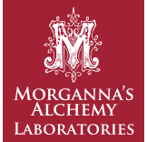

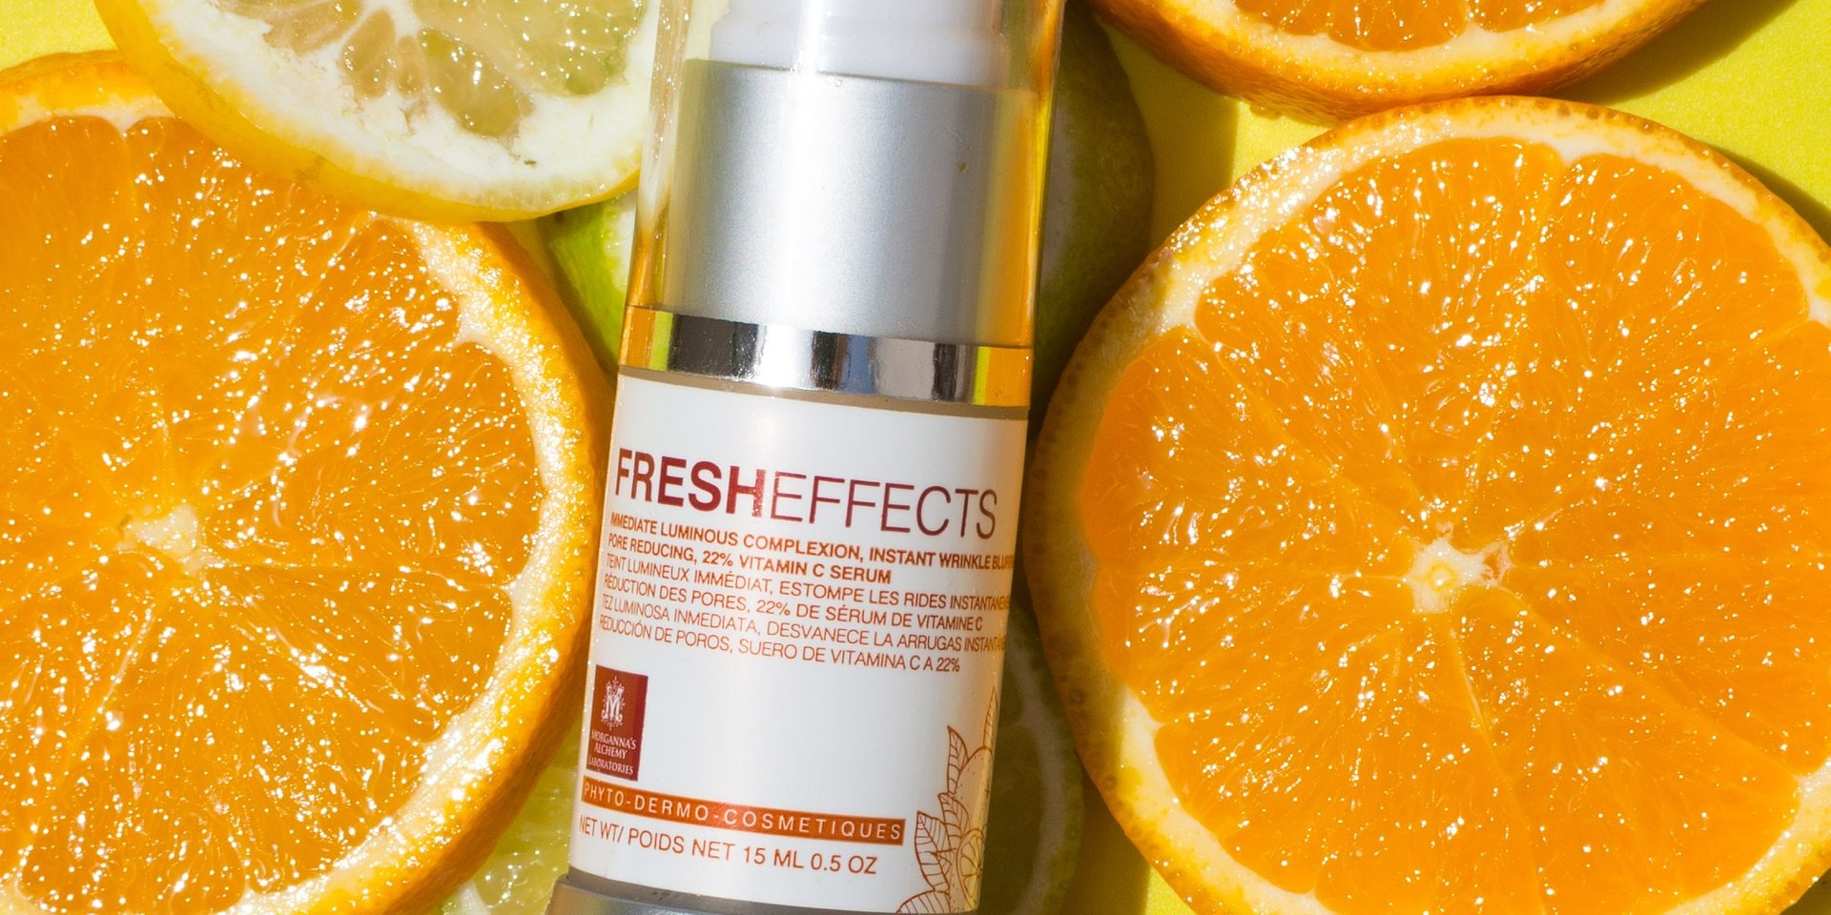

Organic skincare line now available in the US

[Tampa, FL May 17, 2021] - Morganna's Alchemy is excited to announce that its full product line is now available to purchase in the United States as of Spring 2021.

After 15 years of success in the European skincare market, Morganna's Alchemy is now available to purchase stateside.

The best-selling anti-aging serum BellaTox is the company's cornerstone product. Created in collaboration with the M6 Boutique in Paris, BellaTox is one of the most innovative and groundbreaking beauty products on the market. After several years of being M6 Boutique's number one selling product, BellaTox is now available to order in the United States.

With over 20 years of experience in international cosmetic research and development, CEO, Founder, and Formulator Maya Hyppolite-Williams has developed a proprietary process called Phyto-Dermo-Cosmeceuticals. This means that multiple highly potent active ingredients are put in synergy, delivering the best possible results in the least amount of time. Wrinkle reduction, acne control, and age spot prevention and removal are achieved with no side effects.

"Morganna's Alchemy has long been dedicated to finding quality natural ingredients from all over the world. Our search has helped us to identify some of the best ingredients that nature has to offer. Simplicity and results are the main drivers behind Morganna's Alchemy."

- Maya Hyppolite-Williams, Founder &amp; CEO

As a COSMOS Eco-Certified company, Morganna's Alchemy uses naturally derived, clinically proven, and cruelty-free ingredients to create fast-acting products. By prioritizing sustainability, efficacy, and traceability, Morganna’s Alchemy is able to craft safe, potent, and natural skincare products that deliver powerful results.

Morganna's Alchemy is a natural luxury skincare brand that crafts proprietary products to defy aging, treat acne, and improve skin health using sustainably sourced ingredients made from plant extracts. Constantly raising the bar in cosmeceuticals, Morganna's Alchemy has won numerous international awards including CosmoProf and the Anne & Stiil Beauty Favorites. For more information, visit www.morgannasalchemy.com.

For more information or to inquire about samples, contact Taylor at taylorw@morgannasalchemy.com

