

THE STORY: Rafael is a formerly homeless Army Veteran who now works for GCVF running our Mobile Veteran Outreach program. Mikey is an Army veteran with one leg, who rides a bicycle, homeless and on the streets. Rafael and his side kick “Leo” the 165 lb Malamute are attempting to get Mikey to accept our care, free services and housing… Mikey has been on the streets of Camarillo for over 7 years….

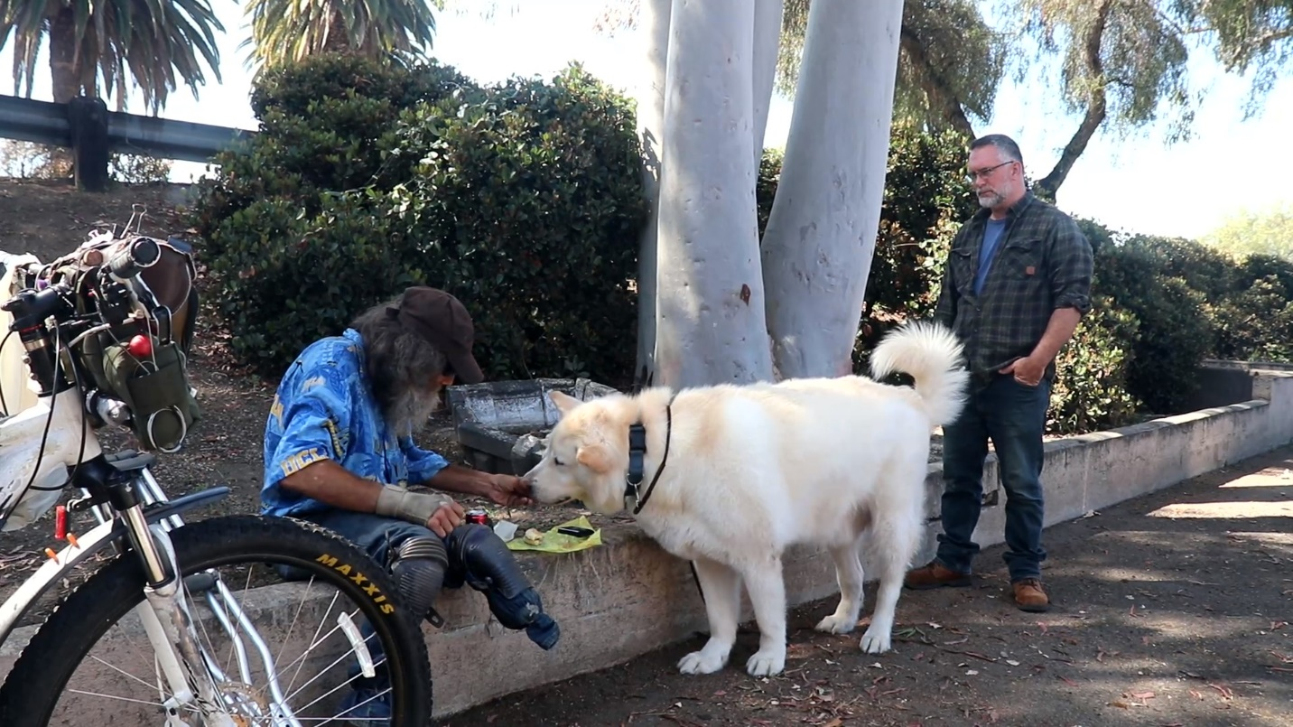

Photo captions for Rafael and Mikey photo
For use as social media post content
The journey of one veteran… from surviving homelessness, to becoming the angel rescuing homeless veterans. What compels a man to take that journey? Find out at www.gcvf.org You’d think that after surviving an injury in the military, living through homelessness, and then completing a college degree… you’d sit back and enjoy a cushy job in a posh office. So why did this guy go right back to the streets where homeless veterans were suffering? www.gcvf.org

An Army veteran survived injury, a botched surgery, and homelessness. He went back and completed his college degree, qualifying for a high-paying career. But now he’s back out on the street, working with the veterans that were written off by everyone else. What compels someone to go from being a homeless veteran to a rescuer of homeless veterans? Rafael’s story is at www.gcvf.org

What compels a veteran who survived homelessness to give up a lucrative career, and go back to the streets to rescue other homeless veterans? www.gcvf.org

