PRESS RELEASE CONTACT: CARRIE LIVINGSTON,
Director of Media Relations, ColinKurtis
Email: carrie@colinkurtis.com
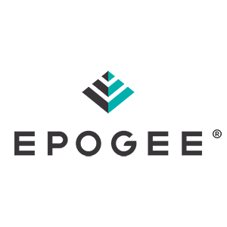
Phone: 815-519-8302
EPOGEE ADDS BRENT CAMPBELL AS SALES DIRECTOR

INDIANAPOLIS, IN, June 03, 2020— Epogee LLC—developer of EPG, the category-defining ingredient technology that eliminates most calories from fat—recently announced the addition of Brent Campbell as their new Sales Director. Campbell will lead sales efforts, as food innovators embrace Epogee’s revolutionary alternative fat technology to make better-for-you foods without any compromise.

“We are delighted to have Brent Campbell join Epogee’s team as our new Sales Director,” said Tom Burrows, CEO of Epogee. “Brent possesses a high degree of technical acumen and is a proven, successful hunter of new business. His strong background in customer collaboration and expertise in solutions selling, makes him a perfect fit for our team. He will ensure we effectively communicate Epogee’s vision to improve the health of society by delivering a solution for the greatest unmet need in food.”

As Sales Director, Brent Campbell will navigate both the strategic and technical selling aspects of account development. He brings more than 20 years of sales experience and considerable expertise in palm oil sustainability, sourcing, and supply chain initiatives. Most recently, Campbell was Key Account Director for Tate & Lyle Food & Beverage Solutions Division and has also worked with leading ingredient companies such as AAK USA and Golden Brands. He earned his Bachelor of Science in Business Administration from Charter Oak State College.

Learn more about the Epogee team and how their new alternative fat technology, EPG, can help you achieve dramatically reduced calories without any compromises in your next food or beverage innovation by visiting: https://www.epogee.com.

###

About Epogee
Epogee strives to improve the health of society by delivering a solution against the greatest unmet need in food: dramatically reduced calories without any compromises. Epogee’s Alternative Fat EPG is an innovative solution to an ongoing problem and is proudly made in the USA. EPG is the one and only alternative fat that can safely and dramatically lower calories without sacrificing taste, texture or appearance.

