PRESS RELEASE CONTACT: CARRIE LIVINGSTON,
Director of Media Relations, ColinKurtis
Email: carrie@colinkurtis.com
Phone: 815-519-8302
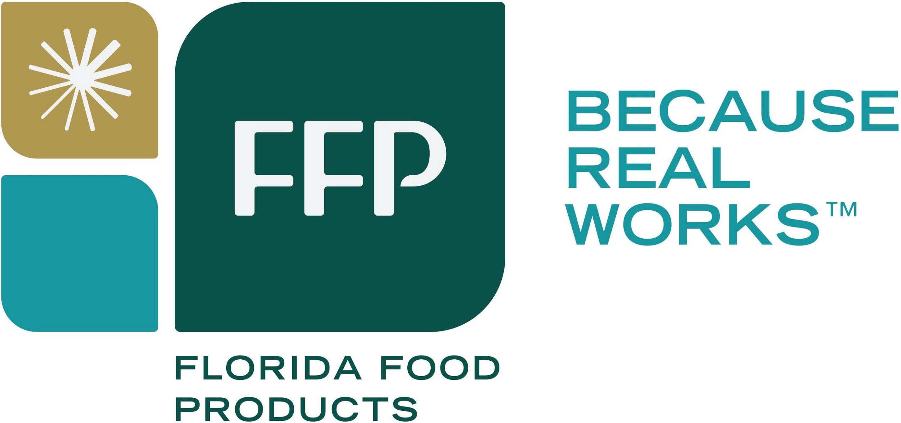
Create Clean And Simple Labels With Ffp’s Fermented Mushrooms
Helps Manufacturers Remove Additives and Reduce Sodium Levels

EUSTIS, FL, June 15, 2021—Florida Food Products (FFP), a leader in clean label food and beverage ingredient solutions, recently showcased Fermented Mushroom Juice Concentrate as part of its line of VegCon™ Vegetable Concentrates. This lacto-fermented mushroom juice concentrate offers manufacturers a clean label replacement for less desirable ingredients such MSG, sodium inosinate and quanylate, and autolyzed yeast extract, while delivering a distinctive umami flavor in a variety of applications such as soups, sauces, dips, plant-based meats, flavor systems, and more.

The demand for mushroom products is increasing, due to the growing recognition of their exceptional dietary and culinary qualities. According to Grand View Research,¹ the global mushroom market reached USD $46.1 billion in 2020 and is expected to grow at a CAGR of 9.5% in the forecast period of 2021-2028. Demand is being driven by the rising number of consumers shifting their diets to include more plant-based alternative sources of protein, as they work to improve their health and overall well-being.

“Our VegCon Fermented Mushroom Juice Concentrate is a fantastic choice for food product developers working to clean up labels in response to consumers’ desire for simple and familiar ingredients on product labels,” said Christopher Naese, Vice President, Business Development, Florida Food Products. “FFP’s fermented mushroom juice concentrate is an innovative clean label alternative to ingredients such as autolyzed yeast extract and MSG. The product will help manufacturers deliver rich and flavorful foods while consumers embrace the health benefits and natural umami flavor that mushrooms provide.”

Mushrooms are considered a superfood and provide a rich, low calorie source of fiber, protein, and antioxidants. Additionally, the savory umami flavor and versatility of fermented mushrooms make them a great clean label ingredient that can also help food manufacturers reduce sodium levels by up to 25%.

“Fermented Mushroom Juice Concentrate is a great way to enhance a variety of applications such as soups, sauces, dips, cooking bases, and plant-based products,” said Naese. “It can also be used at higher levels to provide a more robust mushroom flavor. We source from local crops at peak harvesting times to deliver ideal flavor, color, and nutrition. Our in-house production offers manufacturers a clear line of sight to the source, along with superior technical service and unmatched flavor quality.”

FFP’s VegCon Fermented Mushroom Juice Concentrate offers many manufacturing benefits including:
- Labeled as “fermented mushroom concentrate” or “natural flavor”
- Reduced sodium content
- Delivers color and mild mushroom flavor
- Increased nucleotides ideal for replacement of several ingredients

FFP delivers a multitude of clean label solutions to meet the needs and desires of customers and consumers across the food and beverage industry. Building on their leadership in natural cures for the meat industry, FFP’s latest innovations include the expanded line of VegCon™ lacto-fermented vegetable juice concentrates and powders, as well as VegStable® Plus, an industry-leading natural phosphate alternative. Their recent acquisition of Amelia Bay, LLC, a leading provider of fresh brewed tea extracts, coffee extracts, and botanicals further expands FFP’s natural flavor and functional expertise and capabilities to include tea and herbal ingredients. Their broad portfolio of ingredients provide food and beverage solutions that offer immune support, digestive health, and natural energy for customers eager to meet and get ahead of growing consumer demands.

For more information on FFP, please visit https://floridafood.com/products/vegcon-vegetable-concentrates/.

###
About FFP
Based in Eustis, Florida, Florida Food Products, Inc. operates a multifunctional production facility and is involved in manufacturing of vegetable juice concentrates and derivatives used in a multitude of food applications from savory to beverages, sports nutrition and meats, and are marketed globally. The Company has offered a portfolio of healthy, natural, clean label solutions for over 60 years. For additional information, please visit Florida Food Products’ website (www.floridafood.com).

¹Grand View Research Report, https://www.grandviewresearch.com/industry-analysis/mushroom-market

