CJ Fentiman
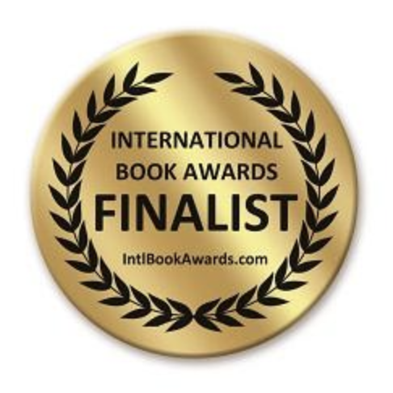

For Immediate Release
Contact name: Tina Nayeri
Phone: 0408 851783
Email: admin@silvervinepress.com
www.silvervinepress.com

“The Cat with Three Passports” recognised by International Book Awards

Sydney, Australia
23rd June 2021

On 18 June, the American Book Fest announced the finalists for the International Book Awards 2021 and among those recognised was the Australian author, CJ Fentiman for her memoir “The Cat with Three Passports”. Published by Silver Vine Press, it follows the journey of an alienated English language teacher navigating the cultural quirks of Japan with the help of three local cats. It’s an insightful look at the complexities of life for foreigners in Japan and how this shaped the author’s understanding of herself and finding her ikigai.

In the announcement, American Book Fest recognised outstanding literary works in over 90 categories, including the Animals/Pets: Narrative Non-Fiction category in which CJ Fentiman was a finalist. The International Book Awards celebrate books from both mainstream and independent publishers, as well as self-published works. Over 2,000 entries were submitted for the awards, with around 400 winners and finalists acknowledged.

Jeffrey Keen, the President and CEO of American Book Fest said: “The 2021 results represent a phenomenal mix of books from a wide array of publishers throughout the world. With a full publicity and marketing campaign promoting the results of IBA, this year’s winners and finalists will gain additional media coverage for the second half of 2021.”

Aside from “The Cat with Three Passports”, CJ Fentiman is the author of “Travelling with Pets” a guidebook that’s now in its 5th edition. She also writes an associated blog that focuses on finding pet-friendly accommodation throughout Australia and was named as one of the country’s Top Pet Blogs by PetSecure. CJ Fentiman’s work has been published in the “The Japan Times”, the “Herald Sun” and “Australian Dogs and Pets Magazine” and she’s the in-house pet travel expert for the PetsForever app. She also works as a staff writer for several major pet food companies.

