**INSTAGRAM**

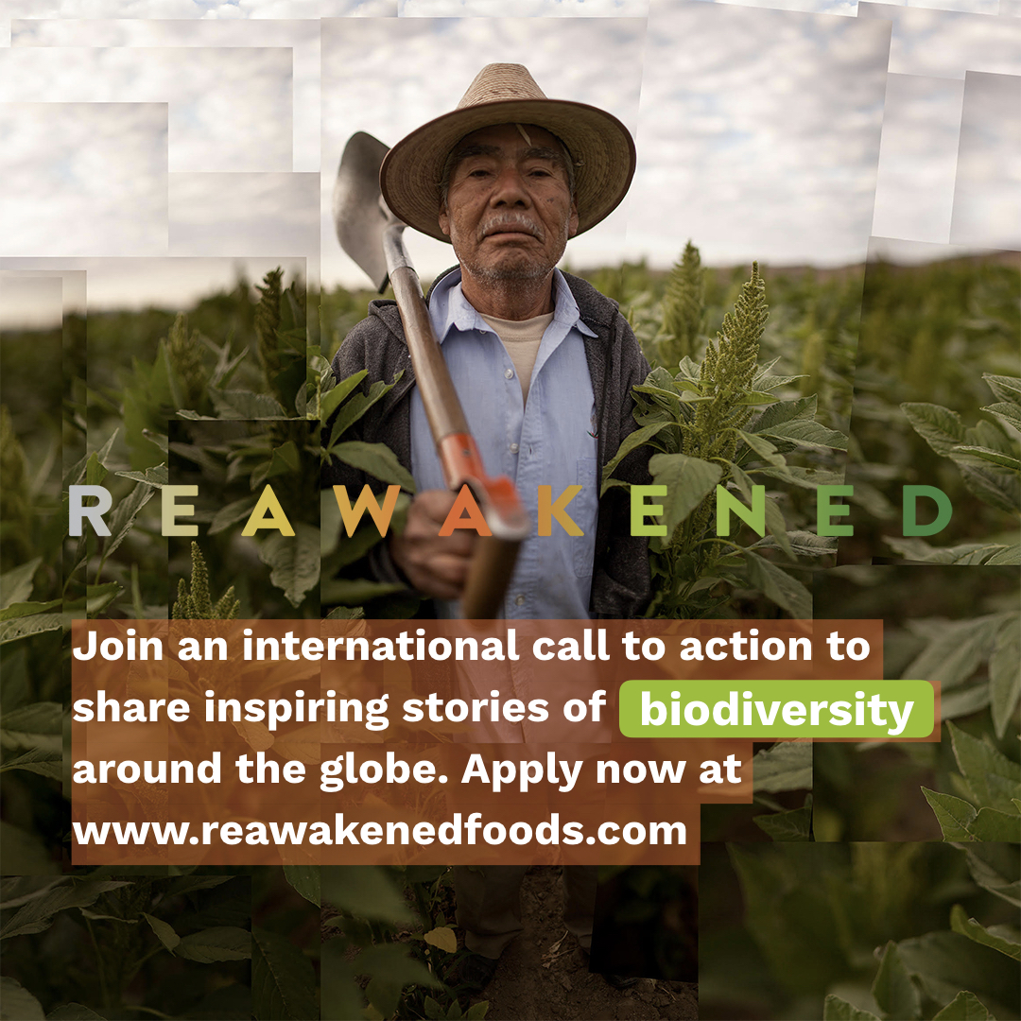

THE REAWAKENED FOODS INITIATIVE is a unique cross-sector partnership that invites storytellers, photographers, filmmakers, designers and writers from across the globe—from Asia to Africa and across South America — to join a global movement and share inspiring stories in defense of biodiversity.

25 Storytellers will be advanced to The Lexicon Total Storytelling Masterclass and learn how to produce location based stories of agrobiodiversity for the initiative.

To join, storytellers can apply through the Reawakened Call to Action page. Check out the link in our bio.

#agrobiodiversity #biodiversity #EatGrowSave #biodiversityconservation #regenerativeagriculture #foodstorytellers #sustainableagriculture #sustainablefarming #sustainablegardening #foodsecurity #regenerativefarming #foodsystems #sustainablefoodsystems #localfarms #locallygrown #naturalfarming #eatlocal #bettertomorrow #foodsecurityforall #foodsecurityproject #generationrestoration #sustainabilitymatters #sustainablefuture #ethicalbusiness #foodproduction #foodsupply #foodjustice #agroecology #goodfoodmovement #endhunger #socialgood #socialimpact #nonprofitorganization #givebacktothecommunity #communitysupport #supportlocalfarmers #saveseeds #climatechangeawareness #soilhealth

**LINKEDIN**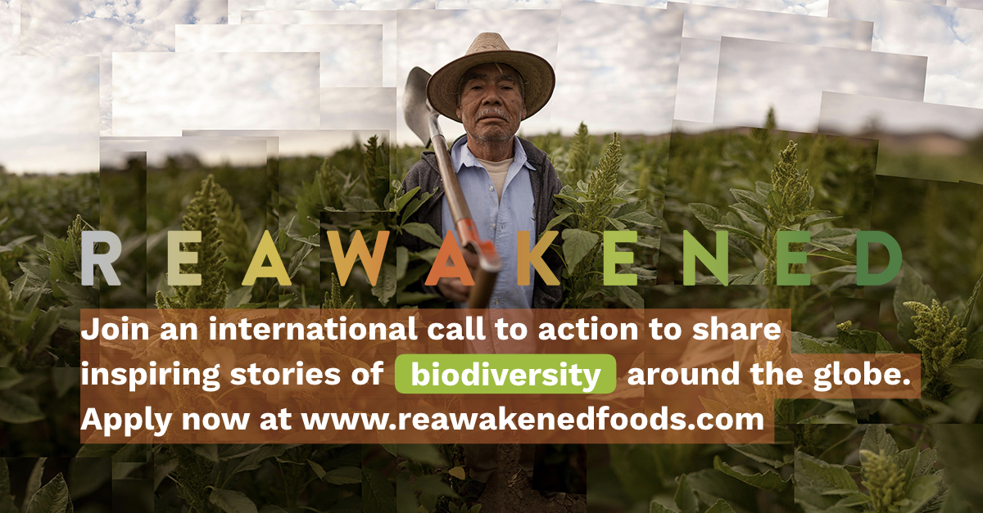

THE REAWAKENED FOODS INITIATIVE is a unique cross-sector partnership that invites storytellers, photographers, filmmakers, designers and writers from across the globe—from Asia to Africa and across South America — to join a global movement and share inspiring stories in defense of biodiversity.

25 Storytellers will be advanced to The Lexicon Total Storytelling Masterclass and learn how to produce location based stories of agrobiodiversity for the initiative.

To join, storytellers can apply through the Reawakened Call to Action page:<https://ourfood.world/reawakened/global-storytelling-initiative/>

#agrobiodiversity #biodiversity #EatGrowSave #biodiversityconservation #regenerativeagriculture #foodstorytellers #sustainableagriculture #foodjustice #socialgood #socialimpact #foodsystems

**FACEBOOK**

THE REAWAKENED FOODS INITIATIVE is a unique cross-sector partnership that invites storytellers, photographers, filmmakers, designers and writers from across the globe—from Asia to Africa and across South America — to join a global movement and share inspiring stories in defense of biodiversity.

25 Storytellers will be advanced to The Lexicon Total Storytelling Masterclass and learn how to produce location based stories of agrobiodiversity for the initiative.

To join, storytellers can apply through the Reawakened Call to Action page:<https://ourfood.world/reawakened/global-storytelling-initiative/>

#agrobiodiversity #biodiversity #EatGrowSave #biodiversityconservation #regenerativeagriculture #foodstorytellers #sustainableagriculture #foodjustice #socialgood #socialimpact #foodsystems

**TWITTER**

We are seeking for Storytellers to join us in the Reawakened Foods Initiative and learn how to produce and share location based stories in defense of agrobiodiversity. Apply here: <https://ourfood.world/reawakened/global-storytelling-initiative/>

#agrobiodiversity #biodiversityconservation #foodstorytellers #EatGrowSave