**FOR IMMEDIATE RELEASE** CONTACT: Carrie Livingston

Email: [carrie@colinkurtis.com](mailto:carrie@colinkurtis.com)

Phone: 815-519-8302

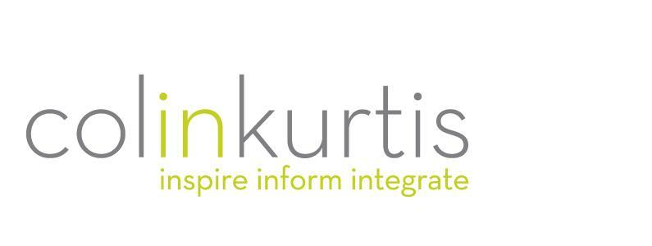

**COLINKURTIS ADVERTISING WINS 2021 DIGITAL & SOCIAL MEDIA AWARD**

(June 29, 2021) Rockford, IL – ColinKurtis Advertising, a leading food industry agency specializing in strategic branding and communication solutions, has recently been named a 2021 Digital and Social Media award winner by PR News and its sister brand, The Social Shake-Up. The campaign for Campfire Marshmallows Great Escape Giveaway won the 2021 Best Use of Facebook Winner for Contest or Game and was selected out of hundreds of entries as the best in digital PR and social media.

“I am so proud of the CK team and excited that our work on behalf of Campfire Marshmallows has been recognized,” said Colin Kampmier, President, ColinKurtis Advertising. “The team created ‘The Great Escape Giveaway’ to generate some real excitement for the Campfire Marshmallows brand. While families were spending more time camping due to the COVID-19 pandemic, it was the perfect time and opportunity to launch a ‘camping essentials giveaway’ campaign.”

The giveaway consisted of a prize package including all the basics needed for a family of four to be able to get outside and explore the great outdoors. ColinKurtis implemented a cross-channel approach using Instagram, Twitter, Pinterest, email marketing, a new landing page on the Campfire website, work with social media influencers and Instagram ads to promote the ‘Great Escape Giveaway’ campaign.

Along with a 270% increase in web traffic, all the campaign's social media channels saw an increase in impressions, engagement, clicks and audience growth. Influencers involved in the effort also had over 200,000 engagements, further increasing brand awareness and engagement for Campfire Marshmallows.

“It is very nice to have our work recognized, yet the real joy is the value we were able to deliver for the Campfire brand,” said Kampmier. “This campaign and resulting excitement increased brand awareness, drove social media engagement and generated a spike in web traffic. We love to create fun campaigns such as this one, but our true reward is the long and fulfilling relationship our agency has built with the Campfire brand over many years.”

For more information on ColinKurtis or to be inspired by some of the agency’s work, please visit <http://www.colinkurtis.com>.

###

***About ColinKurtis Advertising***ColinKurtis Advertising, a Rockford, Illinois-based company, is a full-service advertising and design firm. The agency strives to provide both business-to-business and business-to-consumer clients with strategic marketing solutions delivered through solid creative direction and concise communication messaging.