Contact: Dina Elliot, President & Co-Founder **FOR IMMEDIATE RELEASE**

Exit One Solutions

O. 239.598.024

C. 201.310.3356

[Dina.Elliot@exitonesolutions.com](mailto:Dina.Elliot@exitonesolutions.com)

[www.ExitOneSolutions.com](http://www.ExitOneSolutions.com)

**DON’T JUST DREAM OF HEALTHY, SMOOTH, PERFECT HAIR!**

**GET IT NOW AT HOME WITH   
KERATIN PERFECT®**

***Powered by KERATIN COMPLEX®*!**

**BOCA RATON, FL** (*July 2021*) – **Keratin Complex** revolutionized the beauty industry with their innovative keratin smoothing treatments and they are doing it again! This time, they want everyone to experience the amazing benefits of salon-quality keratin-enhanced products from the comfort of home and enjoy their very best hair day EVERY DAY.

**Keratin Perfect** hair care is fueled by salon-quality keratin and features easy, customizable   
3-step regimens that deliver healthier hair with each use.

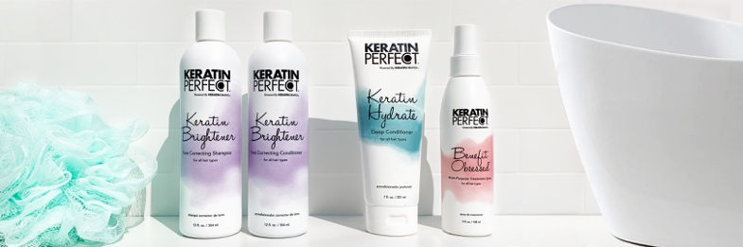Step 1: Choose the best shampoo and conditioner duo for your hair type.

Step 2: Customize your finish by choosing your blow-dry aid.

Step 3: Complete your regimen with a weekly keratin-enhanced hair mask.

**Keratin Perfect** was developed by a team of scientists and delivers unique, results-driven formulas backed by *KeratinPro Technology* that seeks out the damaged, porous parts of the hair cuticle and fills in these areas with a salon-quality keratin. **Keratin Perfect’s** lightweight, keratin-enhanced formulas cater to all hair types and textures —eliminating frizz, making the hair easier to style, and providing complete hair health and optimal condition.

**Keratin Perfect** contains:

* **KeratinPro Technology**, a proprietary keratin-enhanced formula that strengthens the hair from within, making it look healthier **instantly**.
* **Salon-quality ingredients** such as high-performing, nourishing extracts, oils and botanicals that deliver luminous shine and youthful, healthy-looking hair.
* **Lush yet lightweight fragrances** - soft floral and fruit-based fragrances that appeal to everyone.
* **Simple to use and delivers immediately visible results**!
* **NO added Sodium Chloride**! We say “no” to salt! Keratin Perfect products are safe for keratin-treated hair and help extend the life of keratin treatments.

“**Keratin Perfect** was designed to deliver the benefits of salon-quality keratin to consumers at home providing them with healthier hair and the ability to experience their version of a “perfect hair day” without going to the salon. Customization is key and we believe our easy 3-step quiz will allow every consumer the ability to personalize their perfect hair care regimen from our collection of salon-quality products at an attractively affordable price point” stated Zoe Hyams, Senior Vice President Marketing, Keratin Perfect.

The **Keratin Perfect** range includes 3 specific duos to cleanse/moisturize, as well as other essential products for amazing at-home results. All shampoos and conditioners are available in 32 oz., 12 oz. and travel-friendly duos.

**Step 1: Choose your shampoo and conditioner**

1. **Keratin Daily Smoothing Duo** - this amazing duo consists of **Keratin Daily Smoothing Shampoo** (12oz/SRP $18) and **Keratin Daily Smoothing** **Conditioner** (12oz/SRP $18) that contain gentle cleansing agents paired with salon-quality keratin to hydrate hair while also fighting frizz. Provides UV protection. Perfect for all hair types and daily use.
2. **Keratin Color Smoothing Duo –** this duo is ideal for color-treated hair and consists of **Keratin Color Smoothing Shampoo** (12oz/SRP $18) and **Keratin Color Smoothing Conditioner** (12oz/SRP $18) is designed to keep color-treated hair smooth, soft, protected and strong while fighting against frizz.
3. **Keratin Brightener Tone-Correcting Duo –** includes the **Keratin Brightener Tone-Correcting Shampoo** (12oz/SRP $22)and **Keratin Brightener Tone-Correcting Conditioner** (12oz/SRP $22). This keratin-powered lavender duo is super-hydrating and gently cleanses while it also fights fading and enhances all hair color shades, especially blonde, grey and silver tones. Be ready to say bye to brass and embrace brighter colors!

Additional specialty products in the **Keratin Perfect** range include:

**Step 2: Choose your blow-dry aid**

**Keratin** **Perfect Benefit Obsessed** (5oz/ SRP $22) **–** Thisis the one product you cannot live without which is why we call it our magic spray! This lightweight, multi-purpose treatment spray tames frizz, repairs damage, strengthens, softens and smooths all day long. Be ready to get obsessed! It is also available in a travel-friendly size (1.7 oz/ SRP $12).

**Keratin Frizz-Free Blow Dry Cream** (2.5oz/ SRP $24) is bursting with keratin that revitalizes hair from inside out, calms unruly strands and boosts manageability to make styling easier, because we all deserve a perfect frizz-free blowout.

**Step 3: Complete your regimen with a keratin-enhanced hair mask**

**Keratin Hydrate Deep Conditioner** (7oz/ SRP $21) is a spa treatment and luxurious ritual for your hair. This vanilla-infused, deep-conditioning masque conditions, moisturizes and prevents breakage, leaving your hair extra soft, nourished and perfect!

The new **Keratin Perfect** range delivers exactly what we all want – healthier, frizz-free hair that we love every day from the comfort of home!

**Keratin Perfect** products areavailable online at [www.keratinperfect.com](http://www.keratinperfect.com) or visit other retailers including Rite Aid, Bed, Bath & Beyond and coming soon to select Target locations. For more information, please visit [www.keratinperfect.com](http://www.keratinperfect.com) or call 888.409.4445.

# # #

For more information, product samples, or to schedule an interview please contact

Dina Elliot at (239) 598.0246 or [Dina.Elliot@ExitOneSolutions.com](mailto:Dina.Elliot@ExitOneSolutions.com)

