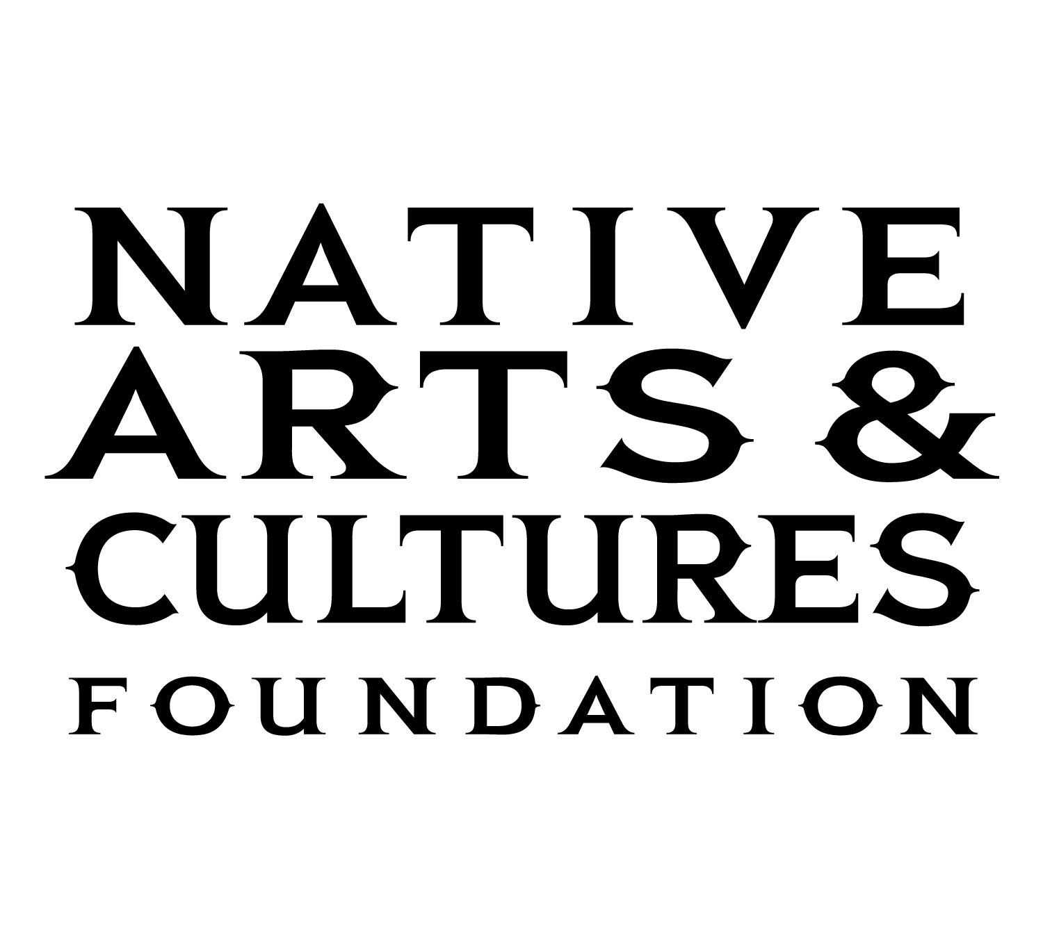

Media Contact:
Barbara Soule
(360) 334-7263
barbara@nativeartsandcultures.org

NATIVE ARTS AND CULTURES FOUNDATION ANNOUNCES NEW LIFT PROGRAM AWARDEES FOR 2021

PORTLAND, Oregon, July 7, 2021 – The Native Arts and Cultures Foundation (NACF) is pleased to announce the first cohort of the LIFT – Early Career Support for Native Artists program awardees. Following a national open call for American Indian, Alaska Native and Native Hawaiian artist applicants, over 100 artists’ applications were reviewed by a panel of arts professionals specializing in dance, literature, film, multi-disciplinary arts, music, performance art, theater, traditional arts and visual arts. Twenty artists were selected to receive a $10,000 one-year award designed to support artists in furthering their work and/or to serve as a launching point in their career. NACF is grateful to the Leon Polk Foundation for their support of the LIFT - Early Career Support for Native Artists program.

“Whether these artists are emerging or not, their work is indicative of the boundless promise of Native creativity,” says Reuben Roqueñi, Director of Transformative Change Programs. “We are inspired by their innovations, their discipline, and their connection to their communities.”

The LIFT – Early Career Support for Native Artists program provides early career Native artists with professional development, marketing support, culturally appropriate evaluation, and a $10,000 award to develop and realize new projects. Support for burgeoning artists is critical in developing fresh voices and envisioning the future of our respective Native practices. In addition, LIFT encourages artists to uplift communities, advance positive social change, point courageously toward environmental sustainability, and foster communal meaning-making.

Selected artists for the LIFT 2021 awards are as follows:

Dance/Choreography
- ShanDien Sonwai LaRance (Hopi/Tewa/Navajo/Assiniboine) will create a 15-20 episode video course for youth on hoop dance, presented as a legitimate dance and fitness exercise.

Fiction/Poetry Writing
- Chelsea T. Hicks (Osage/Wazhazhe) is creating a poetry collection in Wahzhazhe (the Osage language) and English.
- Jessica (Tyner) Mehta (Cherokee Nation) will write a 50+ page book of poems plus create a temporary art installation.
- Gretchen Potter (Tonawanda Seneca) will write a collection of 14 linked stories.

Film/Video
- Taylor Antone (Akimel O’odham, Gila River Indian Community) will create an animated documentary short film series focusing on life stories from the Gila River Indian Community.
- Maya Rose Dittloff (Blackfeet and Mandan/Hidatsa) will write, direct and produce a short narrative film centering on the strength of Native women.

Multi-Disciplinary Arts
- Dawn E. LeBeau (Oóhenunpa Itázipčo) will honor every fluent Lakota language speaker on the Cheyenne River Nation in a series of photographic portraits and video interviews.
- Henu Josephine Tarrant (Rappahannock, Kuna & Ho-Chunk) will create a concept video album—a story of coming into Indigenous Womanhood in the post-apocalyptic cyber city of New York City.

Music
- Kalalea Ka’uhane (Native Hawaiian) will create original music for an EP and a short-story film that gives voice to the struggle of the Native Hawaiian community.
- Olivia Komahcheet (Comanche/Otoe) will mentor an aspiring Native musician to develop a music video, a song release, and a community-based project.

Traditional Arts
- Cecily Engelhart (Ihanktonwan/Oglala) will collaborate with a mentor artist to create and pass on Lakota parfleche to a group of Native women in a healing-based learning circle.
- Ursala Hudson (Tlingit) is working on a project that includes weaving four regalia ensembles in Northwest Coast Chilkat and Ravenstail textiles.
- Carrie G. Lind (Cherokee Nation/Shawnee) will record seven conversations with spiritual leaders across the US and create seven pots inspired by the journey using local clays.
- Keoneʻulaokamakauhi Keliʻiokalani Teawenohoitalani Mākua (ʻŌiwi Hawaiʻi) will travel to four Hawaiian Islands to offer workshops and document traditional designs in a repository for his students continued learning and benefit.
- Monica Jo Raphael (Anishinaabe-Sicangu Lakota) will teach quillwork to people from three Oklahoma Anishinaabe tribes who were removed to Oklahoma due to the Removal Act of 1830.
- Kellen Trenal (Niimíipuu, Nez Perce and Black) will produce a collection of beaded accessories, jewelry, and traditional regalia pieces on brain-tanned hides and trade cloth wools.

Visual Arts
- Del Curfman (Crow Tribe of Montana) will develop a new body of work that will focus on Native people who live off their traditional reservations.
- Erin Ggaadimits Ivalu Gingrich (Koyukan Athabascan & Iñupiaq) will create new work examining processes of transformation in Alaska’s wildlife through carved masks and sculptures.
- Camas Logue (Klamath, Modoc, Yahooskin) will create a series of paintings made with earth-based pigments and dyes collected from his tribal homelands in southern Oregon.
- Richard D. York (Cherokee Nation Tribal Citizen) will develop seven new paintings on rawhide-covered hoop drums and wood panels, symbolizing the connection and disconnection to his home and culture.

About the Native Arts and Cultures Foundation
The Native Arts and Cultures Foundation’s mission is to advance equity and cultural knowledge, focusing on the power of arts and collaboration to strengthen Native communities and promote positive social change with American Indian, Native Hawaiian, and Alaska Native peoples in the United States. The Foundation has supported over 300 artists and arts organizations in 34 states and the District of Columbia. To learn more about the Native Arts and Cultures Foundation, visit www.nativeartsandcultures.org.

####

