PREMIER PRODUCTIONS ANNOUNCES ELEVATION NIGHTS
FALL 2021 TOUR

EIGHT-CITY ARENA TOUR FEATURES
ELEVATION WORSHIP AND STEVEN FURTICK
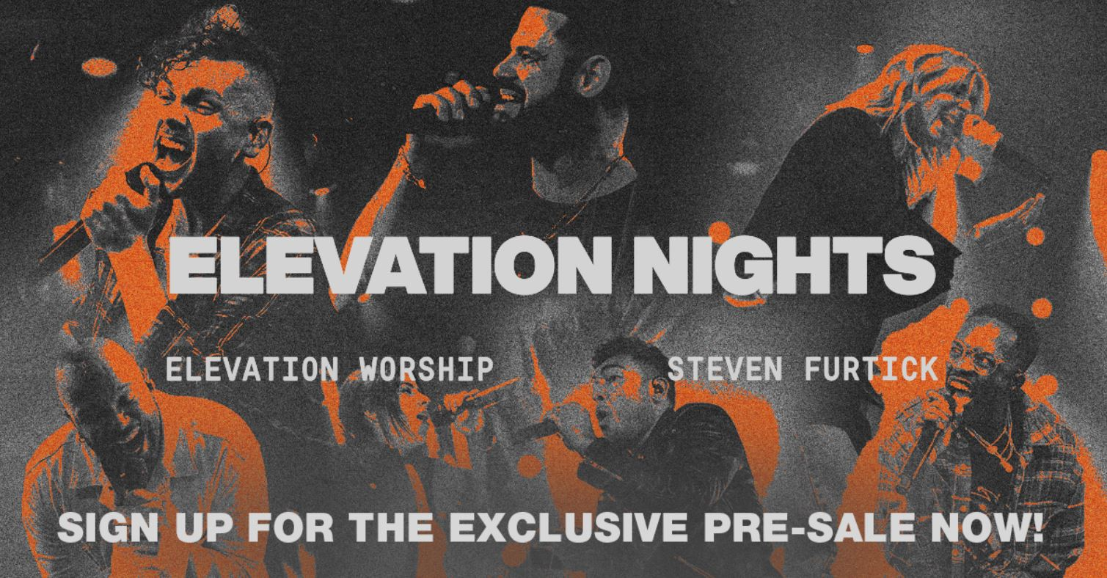
NASHVILLE, Tenn. (July 8, 2021) – Premier Productions announces Elevation Nights, a new tour featuring Elevation Worship and Steven Furtick. Elevation Nights brings the powerful worship experience of Elevation Church into arenas across the country this fall.

After a cancelled 2020 tour and almost 15 months of minimal worship services, in an unprecedented way Elevation Nights is set to lift your spirits with a message of faith, hope and love.

“We’re filled with expectation about what these nights will hold. It’s been way too long since we’ve been able to come together and worship in other cities and we’re believing for unforgettable, hope-filled moments in God’s presence. Having Pastor Steven out sharing a word from God every night is going to be amazing, and there are A LOT of songs that we haven’t had the chance to lead outside of church here in Charlotte because of the pandemic, so we’re ready to RATTLE! with everyone! Can’t wait to see all that God does in these cities this fall,” says Elevation Worship’s Chris Brown.
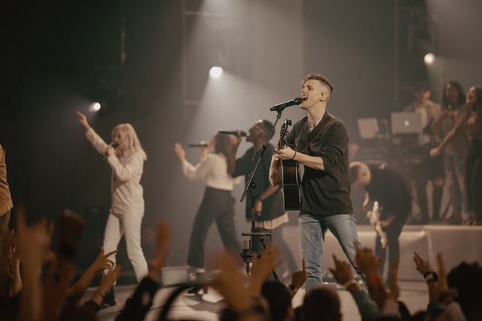
Audiences can sign up for the exclusive pre-sale now at elevationnights.com or https://arep.co/t/elevationnights. People who sign up for the pre-sale will be entered into an extraordinary contest to earn points to win two tickets to the tour location of their choice, access to a special Q&A and a flyaway experience to Elevation Church in Charlotte, NC for the next Elevation Worship live recording. Other winners will receive free tickets and early access to unreleased music from Elevation Worship. Tickets go on sale to the public on July 15 at 10:00 a.m. local time.

Jonathan Roberts, Sr Talent Buyer Premier Productions adds ”Elevation Worship and Pastor Steven Furtick have been global leaders in writing songs for the church and pointing people to Jesus. We are thrilled to see Elevation Nights back on the road, filling up arenas around the country with a common purpose and passion”

This tour is more than a concert, but a full worship experience as Furtick preaches and Elevation Worship leads some of their hit songs including “Graves Into Gardens,” “RATTLE!,” “Do It Again,” “The Blessing” and others. The eight-city arena tour will kick-off on Oct. 26 in Atlanta, Ga. and will stop in Nashville, Tenn., Tulsa, Okla., Fort Worth, Texas, Houston, Texas, Orlando, Fla., Sunrise, Fla., before the final show on Nov. 4 in Jacksonville, Fla.

About Elevation Worship:
Elevation Worship is the worship ministry of Elevation Church, a multisite church based in Charlotte, N.C. led by Pastor Steven Furtick. Elevation Worship has produced 12 albums that include American Christian radio no. 1 song “Graves Into Gardens”, the RIAA Gold Certified song “The Blessing”, RIAA Platinum Certified and American Christian radio Top 5 song “O Come to the Altar” and the RIAA Gold Certified song “Do It Again.” The group currently has ten songs in the CCLI Top 100 list. This ministry is passionate about producing songs for the local church that connect others to God. Their main priority is to create an atmosphere of worship so people can encounter Jesus in a real and personal way.

About Steven Furtick:
Steven Furtick is a pastor, songwriter and New York Times best-selling author. As founder and lead pastor, he has helped grow the multi-site Elevation Church into a global ministry through online streaming, television and the music of Elevation Worship. He holds a master of divinity degree from Southern Theological Seminary and is the author of Crash the Chatterbox, Greater, Sun Stand Still, (Un)Qualified and Seven-Mile Miracle. Pastor Steven and Holly live in Charlotte, N.C. with their two sons, Elijah and Graham, and daughter, Abbey.

About Premier Productions:
Founded in 1996, Premier Productions has sold over 20 million tickets to patrons. Premier has been a Top 20 global promoter and has produced more than 2,000 concerts and events in the past five years. Pollstar named Premier the #1 faith and family independent promoter in the last 10 years. Producing events that move the soul both nationally and internationally, Premier is proud to have helped raise more than $271 million to improve the lives of children and communities in 100+ countries worldwide. Whether it’s a large multi-day festival, sold-out concert or intimate conference, Premier seeks to positively impact the lives of every attendee so they leave encouraged, happy and hopeful. Premier is currently promoting acts including Hillsong UNITED, Dude Perfect, Lauren Daigle, Hillsong Worship, Baby Shark, Casting Crowns, Chris Tomlin, Sadie Robertson, Elevation Worship, Kari Jobe Bethel Music and many more.

Media Contact:
Jennifer Willingham, jennifer@EPIC.inc, 615-483-4729

###

