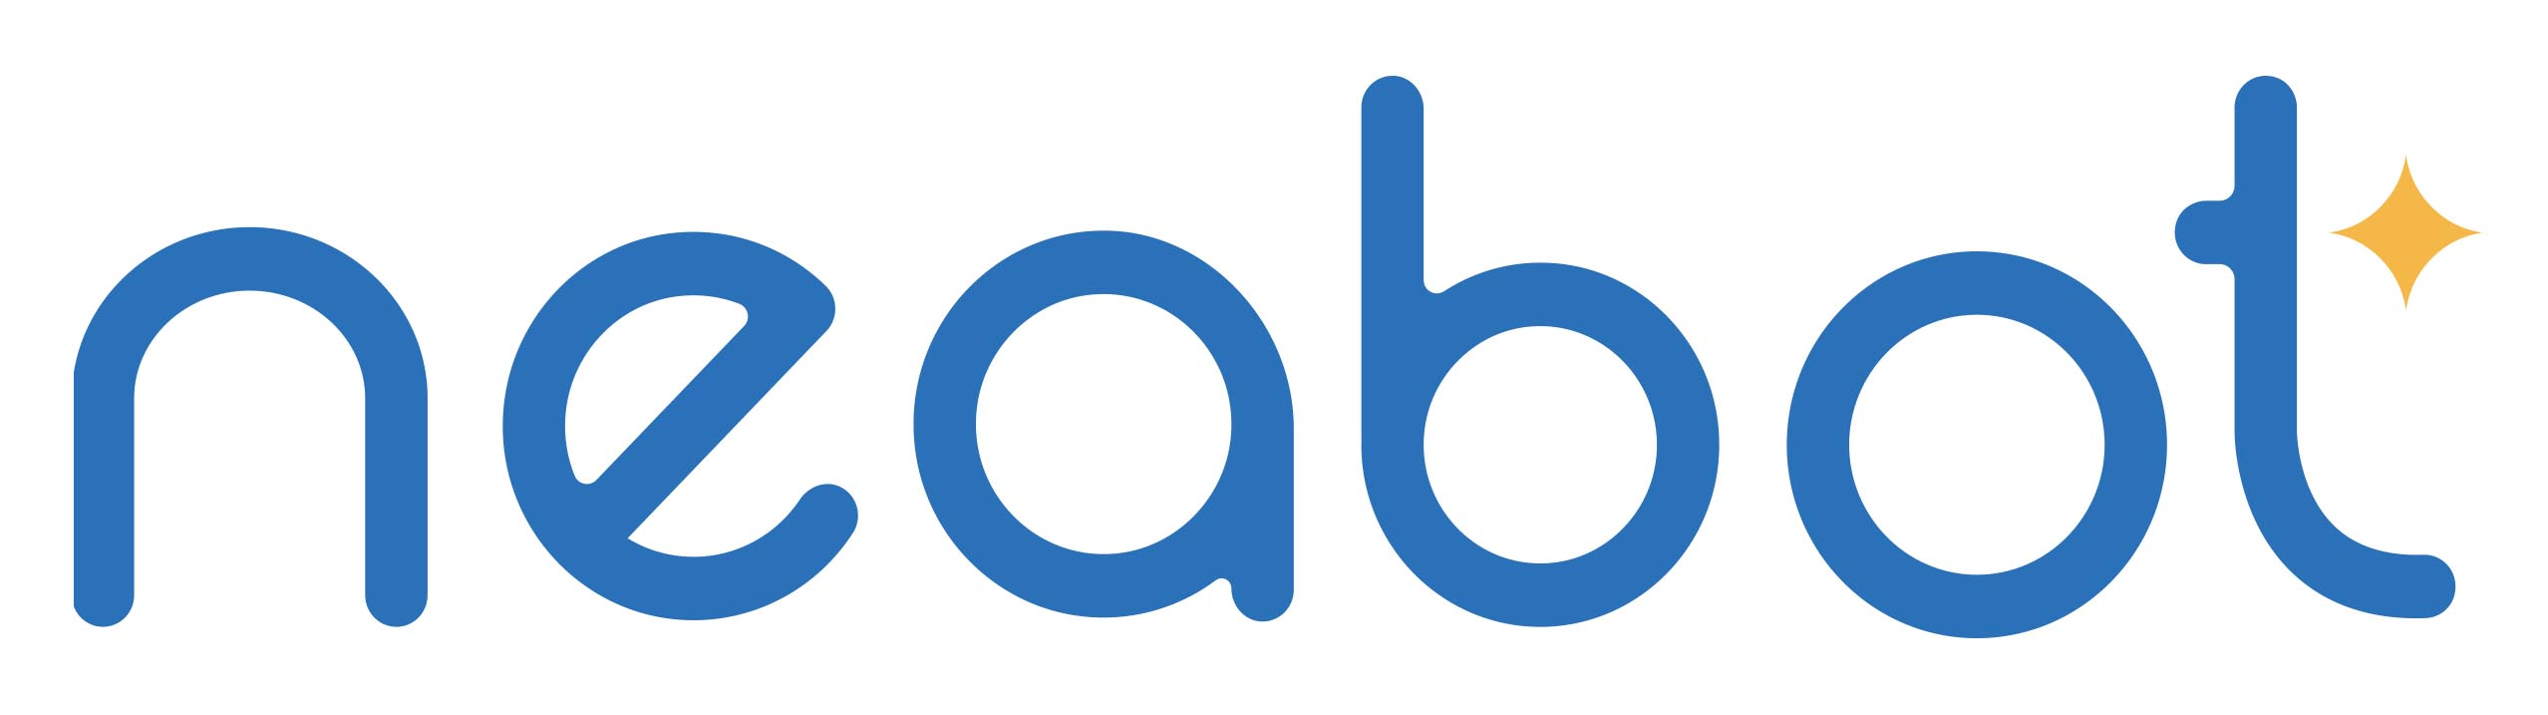

New Neabot P1 Pro All-in-One Pet Grooming Kit and Vacuum is a Must Have Tool for Do it Yourself (DIY) Pet Grooming and Professional Groomers

Professional all-in-one grooming clippers and vacuum removes 99% hair while grooming

(Los Angeles, CA) Neabot P1 Pro ™ is the newest pet grooming product from Neabot Tech, maker of smart home cleaning devices. The Neabot P1 Pro clips and grooms pets and vacuums in one easy to use unit. The all-in-one professional grooming kit is equipped with 5 grooming tools for cats and dogs. The product addresses the problems with grooming by eliminating messy pet hair, excessive noise and cumbersome grooming tools.

Over 65% of households in the United States own a pet. The pet grooming industry in the United States is valued at $7 billion in annual revenue (IBISWorld). Many pet owners are looking for new ways to save money and care for their furry companions. This has led to an increase in Do-It-Yourself (DIY) grooming nationwide. Grooming pets regularly can reduce dust, dander, make your pet look their best, increase bonding between owners and their pets and reduce allergens.

Human allergies to dogs and cats affect 20% of the worldwide population (According to a 2018 study by the National Center for Biotechnology Information) and are a growing public health concern as these rates increase. Regular grooming and reducing pet hair and dander can reduce the symptoms associated with allergies.

Benefits of the Neabot Pet Grooming kit & Vacuum
- Pet grooming clippers are equipped with 5 tools: Grooming brush, de-shade brush to prevent damaging the topcoat while promoting a soft, smooth, healthier skin and coat for the pet. There are also Trim and collection tools. There is even a tool to vacuum and brush for pets’ feet.
- The electric clipper provides excellent cutting performance; Nozzle head and cleaning brush can be used for collecting pet hair falling on the carpet, sofa and floor.
- Low noise design.
- 4 comfort guard combs. The adjustable clipping combs are changeable for clipping hair of different lengths.
- After sales service - 1 year warranty and 45 day no-worry return. Neabot offers 7 day-a-week 24-hour service after purchase.
- Regular grooming and reducing pet hair and dander can reduce the symptoms associated with pet allergies.
- Do-It-Yourself (DIY) dog grooming is on the rise and even more since the Pandemic. Pet owners are interested in saving money, and are investing in grooming tools to care for their pets.
About Neabot

The Neabot P1 Pro Pet Grooming Kit & Vacuum is a new product from Neabot Tech, a maker of smart home cleaning devices. The advanced technology used in the P1 Pro helps pet owners brush and vacuum dirt away, save money, easily remove undercoat, reduce matting and hotspots for a healthier coat and happier pet. The Neabot P1 Pro MSRP is $169.99 and is available on Amazon and on the Neabot website. Wholesale inquiries are welcome. Please visit www.neabot.com for more information.

For Press Inquiries

Sandra Evans
Neabot Marketing & PR
Tel 415 501 9101
sandra@wirenotebooksf.com

keywords: pet grooming, pet vacuum, all-in-one clippers and vacuum, dog and cat grooming, new pet products, pet products, hair and pets, allergies and pets

###

