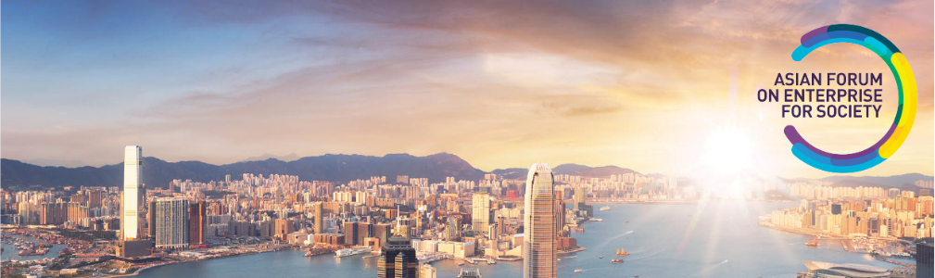

MEDIA RELEASE

For immediate release

**GLOBAL CONFERENCE**

**ON ASIA’S FUTURE BEYOND THE PANDEMIC**

From the 21st to the 24th September 2021, the **Asian Forum on Enterprise for Society (AFES) 2021** will explore how business and society can work together to create better and stronger communities in the wake of the pandemic.

With the theme “**ASIA’S FUTURE RE-IMAGINED”**, AFES 2021 will feature business, community and thought leaders from across the Asia Pacific region to address the big questions shaping Asia’s future. The conference will be virtual and livestreamed across Asia and beyond.

AFES 2021 is convened by two leading Filipino institutions - the Ramon V. Del Rosario Sr. Center for Corporate Responsibility at the Asian Institute of Management and the Ramon Magsaysay Award Foundation, in strategic partnership with Asia Inc Forum from Brunei.

The program, which will span four days in September, includes cutting edge conversations and debates on Asia’s place in a Post Pandemic world, the Future of Work, Technology and Inclusion, Social Change, Energy Transition, Financial Access for the Unbanked, the Future of Globalization and the Lessons from COVID-19.

Among the global thought leaders who will speak at AFES 2021 are **Dr. David H. Autor**, Co-author of “The Work of the Future: Building Better Jobs in an Age of Intelligent Machines” (2022); **Dr. Damon Centola**, Author of “Change: How to Make Big Things Happen” (2021); **Dr. Parag Khanna**, Author of “The Future is Asian” (2019) and advisor to more than 30 governments; **Dr. Aditi Nerurkar**, internationally recognized expert on stress, resilience and mental health during the Covid-19 pandemic and Co-director of the Clinical Clerkship in Community Development of Harvard Medical School; and **Andrew Wear**,Author of “Recovery: How We can Create a Better, Brighter Future after a Crisis” (2021).

“AFES 2021 will be world-class, substance driven, diverse and inclusive. It will aim to provide thought leadership in a world ravaged by the pandemic” said Ambassador Jose L. Cuisia Jr. who is the Chairman of the RVR Center for Corporate Responsibility at the Asian Institute of Management.

Supporting AFES 2021 are Ayala Corporation, BDO Unibank, International Container Terminal Services, Inc. and Metro Pacific Investments Corporation as Host Sponsors, ABS-CBN Corporation, First Philippine Holdings Corporation, PHINMA Corporation and Shell companies in the Philippines as Gold Sponsors, and the Global Shapers Community, Makati Business Club and Young Professionals Network Brunei as Association Partners.

For information on the program and how to attend, visit [**www.asiareimagined.com**](http://www.asiareimagined.com)**.**

---- end of media release ---

AFES 2021 media release

dated July 27, 2021

For inquiries, please contact:

Dayen Tecson

Manager, Regional Programs, Asia Inc Forum

Email: dayen.tecson@asiaincforum.com