**FOR IMMEDIATE RELEASE** CONTACT: Carrie Livingston

Email: [carrie@colinkurtis.com](mailto:carrie@colinkurtis.com)

Phone: 815-519-8302

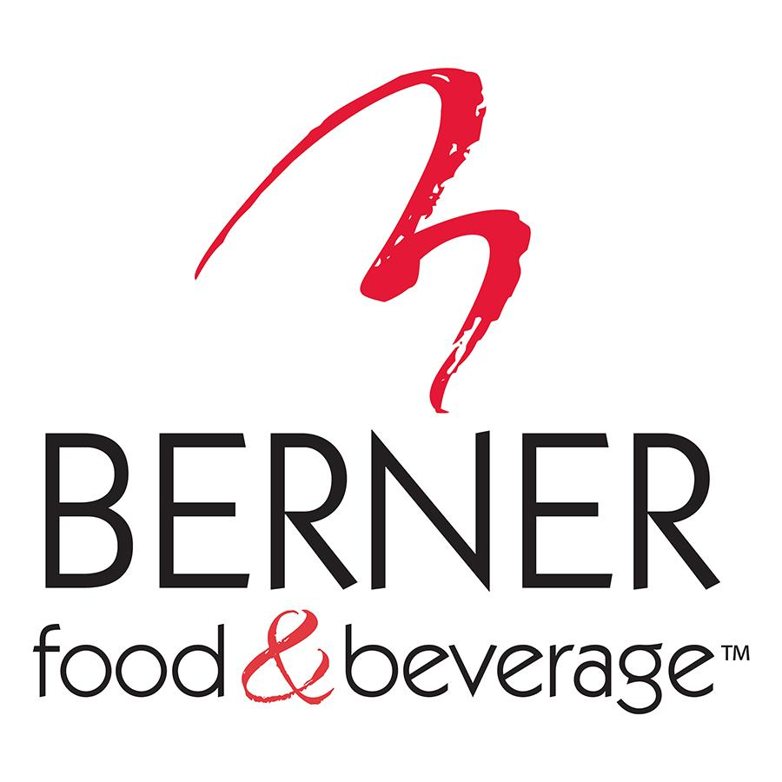

**BERNER NAMES KELLY DIAMOND AS VICE PRESIDENT OF OPERATIONS**

**Dakota, IL** – (August 11, 2021) - Berner Food & Beverage LLC (Berner), a leading private label and contract manufacturing supplier of quality food and beverage products, announced Kelly Diamond has been named Vice President of Operations.

“Kelly Diamond is a valued member of our team, and I can’t wait to see the impact her efforts as Vice President of Operations will have on our dynamic organization,” said Kurt Seagrist, Chief Executive Officer, Berner. “She is a proven performance-driven operations and continuous improvement leader, and she really focuses on team development. We are confident that with Kelly’s experience and dedication, she will deliver excellent operational results for the Berner team and our customers.”

As Vice President of Operations, Kelly Diamond is responsible for overseeing day-to-day company operations while she works to define and implement operations strategy, to further evolve Berner processes. She manages quarterly and annual budgeting processes with P&L responsibilities, while monitoring performance to proactively identify efficiency issues and propose solutions. Diamond uses her years of experience, knowledge of all phases of operations and cross functional collaboration to deliver sustainable best-in-class results.

Before joining Berner in 2017, Kelly Diamond spent nearly a decade at Dean Foods. She also brings experience from positions at Woodward Inc. and Anderson Packaging Inc. She earned a Bachelor’s Degree in Technical and Scientific Communication from Michigan Technical University and a Master of Business Administration from Northern Illinois University.

For more information on Berner Food & Beverage, please visit <https://bernerfoodandbeverage.com>.

###

**About Berner Food & Beverage**

Berner Food & Beverage is a leading private label supplier of quality food and beverage products to a majority of the top retail chains across all trade channels. They provide a single source of supply for both Store Brand products and Contract Manufacturing. Their recent 200,000 sq. ft. production and warehouse addition increases capabilities, making Berner Food & Beverage a single-source partner for food and beverages including processed dips, sauces, aerosol cheese, and RTD coffees and teas. Their facilities are USDA approved, SQF2000 Level III, HACCP certified, and meet the demanding standards of virtually every major retailer in North America.