FROGWORKS Ranked #1 With NEXTGEN 101

September 1st,2021: Frogworks has been named number one for the world’s premier managed service providers on the prestigious Channel Futures 2021 NextGen 101 rankings.

The NextGen 101 list, honors industry-leading managed services and technology providers who are driving a new wave of growth and innovation for the tech channel via the groundbreaking solutions they deliver for their customers.
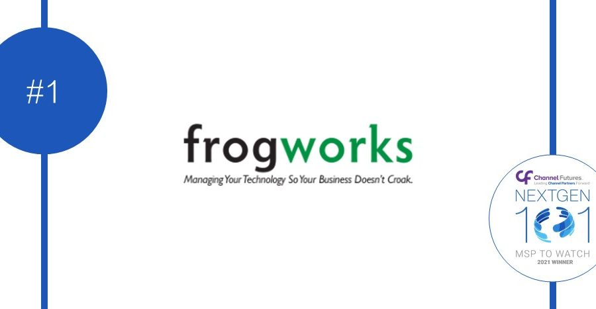

Channel Futures is pleased to name Frogworks #1 to the 2021 NextGen 101 Ranking.

“Frogworks is honored to be receiving first place in Channel Futures 2021 NEXTGEN 101 awards. Through this challenging year we brought it upon ourselves to keep providing consistent affordable fast support. To be recognized in our efforts during an exceptionally challenging time is a great achievement for us.”

- Alex Beam, Owner, Frogworks

“The NextGen 101 is designed specifically to honor partners dedicating resources to building out their practices — all while maintaining the integrity of their core businesses,” said Allison Francis, editor and content producer at Channel Partners and Channel Futures. “Given that these companies represent the future of the technology channel and IT industry, the Channel Futures NextGen 101 are the most watched of all organizations in the channel today.” said Robert DeMarzo, vice president of content for Informa Tech Channels

The data collected by the annual NextGen 101 and MSP 501 drives Channel Futures’ market intelligence insights, creating robust data sets and data-based trend reports that support our editorial coverage, event programming, community and networking strategies and educational offerings.

Background

The 2021 MSP 501 and NextGen 101 lists are based on data collected by Channel Futures. Data was collected online from March 1 through May 24, 2021. The MSP 501 list recognizes top managed service providers based on metrics including recurring revenue, profit margin and other factors.

About Frogworks

Frogworks provides trusted leader in IT Support for Northern Virginia, Maryland, and Washington DC since 2002 for unlimited, Flat-Rate IT Support. “One Company Revolution” We commit ourselves to delivering fast, affordable computer network support from technicians who know their stuff. We leverage the combined skills, expertise, and knowledge of hundreds of IT companies to tackle your IT problems quickly, so you can simply focus on growing your business.

The 2021 MSP 501 and NextGen 101 lists are based on data collected by Channel Futures. The MSP 501 list recognizes top managed service providers based on metrics including recurring revenue, profit margin and other factors.

