FOR IMMEDIATE RELEASE CONTACT: CARRIE LIVINGSTON,
Director of Media Relations, ColinKurtis
Email: carrie@colinkurtis.com
Phone: 815-519-8302

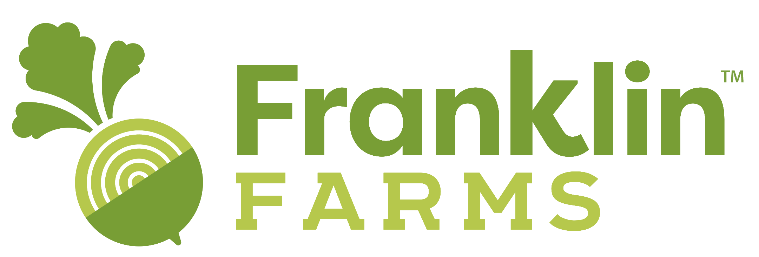

Franklin Farms Launches Exciting New Line of Chickpea Products–
Delicious and Healthy Meal Solutions Now Include Chickpea Tofu

PARSIPPANY, NJ – August 31, 2021 – Franklin Farms™, a division of Keystone Natural Holdings, is pleased to introduce a new line of chickpea products to its portfolio of plant-based offerings. As the plant-based food market continues to grow and diversify, the new line of tofu made from chickpeas offers consumers soy-free options that are low-fat and allergen-free. Consumers will enjoy having additional plant-based meal options, along with the various health benefits provided by adding chickpeas to their diet and lifestyle.

A recent Mintel report indicates the flexitarian lifestyle continues to become a global phenomenon among all generations, especially Gen Z, with “49% of Gen Z trying to add more plant-based proteins to their diet, versus 38% of other generations. As more consumers seek ways to maintain or improve their wellness, plant-based proteins such as chickpeas, lentils, quinoa, nuts, edamame, and soy products are growing in popularity.

“Our team is excited to introduce Chickpea Tofu to our portfolio of plant-based offerings,” said Kenny Sung, CEO of Keystone Natural Holdings. “With the rising number of consumers looking to increase their plant-based protein intake paired with the on-trend growth of the chickpea, these innovative products align well with market trends. Chickpeas are a nutrition-packed powerhouse and are set to replace cauliflower as the latest food trend in 2021. The versatility of the chickpea combined with its familiar delicious taste and health benefits are all key components driving its popularity.”

As consumers continue to seek out new plant-based foods to try at home, Franklin Farms Chickpea Tofu is sure to excite taste buds and ease meal prep. These products are easy to use and require no draining or pressing; they can be cubed or sliced, so consumers can quickly and easily enjoy them in wraps, salads, soup, tacos, and more.

Franklin Farms Chickpea Tofu offer consumers a product that is plant-based, vegan, non-GMO, cholesterol free, gluten free, kosher, and soy free. They are available in several flavor-forward options including:
- Original Chickpea Tofu, medium-firm in texture, with a creamy, melt-in-your-mouth consistency
- Peppadew Pepper® Chickpea Tofu, offering a kick of zesty spice

“These innovative offerings are exciting news for consumers who seek a soy-free diet, as they can now enjoy our Chickpea Tofu,” said Cindy Wong, Vice President of Sales, Franklin Farms. “Now more than ever, consumers are seeking meals that are familiar, yet flavorful, while still providing health and nutritional benefits. A leading powerhouse in plant-based food, chickpeas are a great addition to any diet as they provide consumers a good source of protein, dietary fiber, magnesium, iron, folate, and phosphorus. Chickpeas are also rich in antioxidants and essential vitamins.”

Wong added, “Chickpeas have a long list of benefits. They are helpful for weight loss, as they are packed with dietary fiber delivering consumers with satisfaction and curb food cravings. Other benefits include lowering cholesterol in support of heart health and the reduced risk of heart disease. Chickpeas also contain selenium, which helps the liver to function properly, allowing it to detox cancer-causing compounds from the body, and the isoflavones found in chickpeas may also reduce the risk of breast cancer. We are really excited to add our new chickpea line to our offering, as this superfood really does it all!”

Franklin Farms has more than twenty years of expertise in plant-based protein foods and uses only the highest quality ingredients and packaging to provide a healthy selection of plant-based products for any meal of the day. Product offerings including veggie patties, meatless meatballs, tofu, seitan, tempeh, edamame vegan jerky, Planty Good Patties, and Ground and Vegan Wraps. Franklin Farms is a proud member of healthy brands under Keystone Natural Holdings, a company devoted to developing authentic, health-conscious, and innovative food.

Franklin Farms Chickpea Tofu will be available in select Albertson and Safeway locations.

To learn more about Franklin Farms and its plant-based product offerings or to find the nearest retail location, please visit www.franklinfarms.com or email for more information.

###
About Franklin Farms
Franklin Farms began over 20 years ago as a simple mushroom farm in Franklin, Connecticut. Since then, they have been creating exciting yet good-for-you meatless meals from field to table. Great ingredients make great foods which is why Franklin Farms starts with flavor-forward, high-quality plant proteins. They offer a range of health-conscious plant-based protein products that span day parts, meal types, and taste profiles. From end to end, Franklin Farms makes it easy and delicious for consumers to cook with and eat great-tasting plant-based proteins. From our farms to a store near you, find the nearest retail location at: https://www.franklinfarms.com/where-to-buy.

