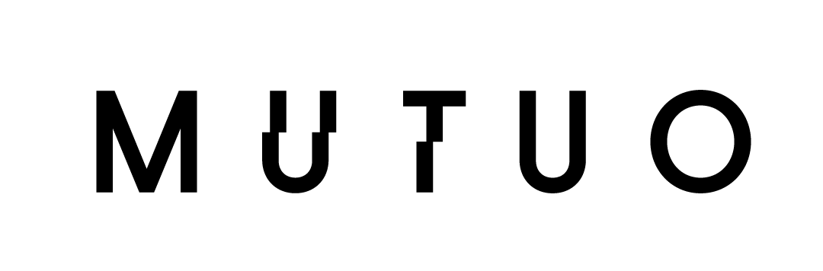

Boyle Tower by MUTUO and Urb-in is an Honorable Mention in Fast Company’s 2021 Innovation by Design Awards

Celebrating 10 years of Innovation by Design, the 2021 honorees include nearly 600 projects, products, and services from Nike, Verizon, Microsoft, and others.

Los Angeles, California, September 22, 2021 – Boyle Tower / MUTUO and Urb-in, were honored in Fast Company’s Innovation by Design Awards for 2021 in the Experimental category.

The 10th anniversary of the awards, which can be found in the October 2021 issue of Fast Company, recognize people, teams, and companies that transform businesses, organizations, and society through design. One of the most sought-after design awards in the industry, Innovation by Design is the only competition to honor creative work at the intersection of design, business, and innovation, recognizing the people, companies, and trends that have steadily advanced design to the forefront of the business conversation.

Our design team researched a new ‘affordable-by-design’ housing typology to be used as a novel tool in the housing ‘toolbox.’ We are proposing reinforced precast box culverts (10’ wide x 8’ deep x 10’ high) commonly used for infrastructure projects as a viable solution for building modern, compact housing.

The research departed from the idea that prefabricated components for large scale infrastructure projects have already achieved an economy of scale. Compared to standard modular construction this system offers smaller modular room-by-room increments, and its monolithic shell acts as both structure, interior and exterior finish.

Boyle Tower stacks five units into a tower configuration with modules that are locally manufactured and transported to the site and craned into place. The complete tower will have its shell assembled in one to two days.
The project has a construction start date scheduled for the first quarter of 2022.

“Boyle Tower is developed around the idea of non-displacement,” said Fernanda Oppermann,” a founding member and principal of MUTUO. “The project keeps an existing four-unit building on the property and proposes five new units on the remaining narrow sliver of land on the site.”

“Design is not just a beauty contest,” said Stephanie Mehta, editor-in-chief of Fast Company. “It’s something that can change the world and create solutions in a time when we face pressing global issues such as systemic racism, climate change, and a global pandemic. Many of these entries showcase these challenges while providing hope for the future through their steadfast commitment to elevate design.”
Honorees for the 2021 awards were selected in the following categories: Apps and Games; Cities; Data Design; Design Company of the Year; Experimental; Fashion and Beauty; Finance; General Excellence; Graphic Design; Health; Home; Learning; Mobility; Packaging; Products; Retail Innovation; Social Good; Spaces and Places; Sports and Recreation; Students; Sustainability; User Experience; Wellness; Workplace; Best Design Asia-Pacific; Best Design Europe, Best Design Middle East, and Best Design Africa; Best Design Latin America; and Best Design North America. New categories included Advertising, Branding, Impact, Materials, Pandemic Response, Real Estate, and Years in Business.
The judges include renowned designers from a variety of disciplines, business leaders from some of the most innovative companies in the world, and Fast Company’s own writers and editors. Entries are judged on the key ingredients of innovation: functionality, originality, beauty, sustainability, user insight, cultural impact, and business impact.

Winners, finalists, and honorable mentions are featured online and in the October issue of Fast Company magazine, on newsstands September 28, 2021.
To see the complete list, go to: https://www.fastcompany.com/innovation-by-design/2021

ABOUT FAST COMPANY
Fast Company is the only media brand fully dedicated to the vital intersection of business, innovation, and design, engaging the most influential leaders, companies, and thinkers on the future of business. The editor-in-chief is Stephanie Mehta. Headquartered in New York City, Fast Company is published by Mansueto Ventures LLC, along with our sister publication, Inc., and can be found online at fastcompany.com.

