**FOR IMMEDIATE RELEASE** CONTACT: Carrie Livingston

Email: [carrie@colinkurtis.com](mailto:carrie@colinkurtis.com)

Phone: 815-519-8302

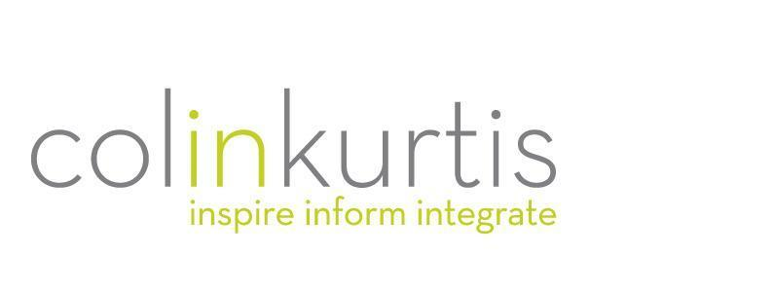

**COLINKURTIS ADVERTISING NAMED 2021 INC. 5000 COMPANY**

(September 29, 2021) Rockford, IL – ColinKurtis Advertising, a leading food industry agency specializing in strategic branding and communication solutions, has recently been named a 2021 Inc. 5000 Company. The Inc. 5000 list rewards the nation’s most successful and fastest-growing private companies and has become the hallmark of entrepreneurial success.

The list represents a unique look at the most successful companies within the American economy’s most dynamic segment—its independent small businesses. Intuit, Zappos, Under Armour, Microsoft, Patagonia, and many other well-known names gained their first national exposure as honorees on the Inc. 5000.

“We are honored to be recognized by the prestigious Inc. Magazine for the first time in our company’s history,” said Colin Kampmier, President, ColinKurtis Advertising. “This recognition demonstrates the dedication that we have to our clients, as well as the hard work and resilience displayed throughout the current pandemic. As a marketing agency that’s focused on delivering high-impact innovative solutions, we celebrate this honor with our clients who have believed in our capabilities to deliver greater value to their marketing efforts. We also recognize and take great pride in our long-term client relationships; we wouldn’t be here today without their partnership!”

Not only have the companies on the 2021 Inc. 5000 list been very competitive within their markets, but this year’s honorees also proved especially resilient and flexible given 2020’s unprecedented challenges. Among the 5,000, the average median three-year growth rate soared to 543 percent, and median revenue reached $11.1 million. Together, those companies added more than 610,000 jobs over the past three years.

Complete results of the Inc. 5000, including company profiles and an interactive database that can be sorted by industry, region, and other criteria, can be found at [www.inc.com/inc5000](http://www.inc.com/inc5000). The top 500 companies are featured in the September issue of *Inc.*

“The 2021 Inc. 5000 list feels like one of the most important rosters of companies ever compiled,” says Scott Omelianuk, editor-in-chief of Inc. “Building one of the fastest-growing companies in America in any year is a remarkable achievement. Building one in the crisis we’ve lived through is just plain amazing. This kind of accomplishment comes with hard work, smart pivots, great leadership, and the help of a whole lot of people.”

For more information on ColinKurtis or to be inspired by some of the agency’s work, please visit <http://www.colinkurtis.com>.

###

***About ColinKurtis Advertising***ColinKurtis Advertising, a Rockford, Illinois-based company, is a full-service advertising and design firm. The agency strives to provide both business-to-business and business-to-consumer clients with strategic marketing solutions delivered through solid creative direction and concise communication messaging.

**About *Inc.* and the Inc. 5000**

**Methodology**

Companies on the 2021 Inc. 5000 are ranked according to percentage revenue growth from 2017 to 2020. To qualify, companies must have been founded and generating revenue by March 31, 2017. They must be U.S.-based, privately held, for-profit, and independent—not subsidiaries or divisions of other companies—as of December 31, 2020. (Since then, some on the list may have gone public or been acquired.) The minimum revenue required for 2017 is $100,000; the minimum for 2020 is $2 million. As always, Inc. reserves the right to decline applicants for subjective reasons. Growth rates used to determine company rankings were calculated to three decimal places. There was one tie on this year’s Inc. 5000. Companies on the Inc. 500 are featured in *Inc.*’s September issue. They represent the top tier of the Inc. 5000, which can be found at <http://www.inc.com/inc5000>.

**About Inc. Media**The world’s most trusted business-media brand, Inc. offers entrepreneurs the knowledge, tools, connections, and community to build great companies. Its award-winning multiplatform content reaches more than 50 million people each month across a variety of channels including web sites, newsletters, social media, podcasts, and print. Its prestigious Inc. 5000 list, produced every year since 1982, analyzes company data to recognize the fastest-growing privately held businesses in the United States. The global recognition that comes with inclusion in the 5000 gives the founders of the best businesses an opportunity to engage with an exclusive community of their peers, and the credibility that helps them drive sales and recruit talent. The associated Inc. 5000 Vision Conference is part of a highly acclaimed portfolio of bespoke events produced by Inc. For more information, visit [www.inc.com](http://www.inc.com).