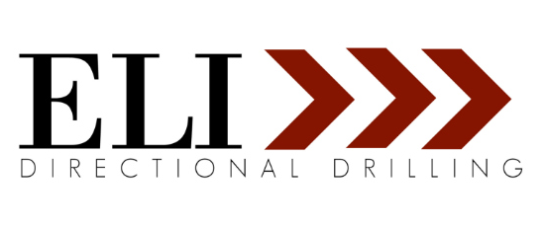

Samantha Clemons Long Makes Inc.’s 2021 Female Founders 100 List

The entrepreneurs on Inc.'s fourth annual Female Founders 100 list have transformed every major industry in America.
St. Louis, Missouri, September 28, 2021—Inc. today announced its fourth annual Female Founders 100 list, honoring the most exceptional, trailblazing, and diverse group of 100 women who powered through adversity in a very tough year and changed the world.

The final list honors entrepreneurs of every age, background, and geography—from very early-stage founders with world-changing ideas to women who have taken companies public, sold them to big buyers, or spent decades building and running their businesses. These women are leading innovative companies in a vast range of global industries, including tech, retail, finance, fitness, health care, consumer products, food, and more.
“I’m honored to be included in Inc.’s 2021 Female Founders 100 List. Five years ago, I committed to building an organization that centered all its stakeholders, not just the ones holding the shares. Despite being a young company, we’ve weathered the challenges of the last year and half with grit and grace and I’m grateful to our entire team at ELI Directional Drilling for their commitment to and pursuit of our shared values,” says Samantha Clemons Long.

Samantha Clemons Long is the CEO & Founder of ELI Directional Drilling, a utility contracting firm based in the greater St. Louis metro. Her firm specializes in the telecommunications sector, having managed tens of millions of dollars of utility infrastructure installation, expanding high-speed internet access to underserved and under-connected communities.

In 2018, Samantha was named one of FOCUS St. Louis’ Emerging Leaders. She also serves on the Board of Directors for Missouri Healthcare for All and St. Louis Arts Chamber of Commerce.

Inc. editors and writers went through thousands of impressive applications that revealed how so many female founders triumphed in a year filled with challenges. The result is an incredible list of founders who have improvised, adapted, and made something from nothing. They join game-changing past honorees Jessica Alba, Tracee Ellis Ross, Rihanna, Shonda Rhimes, and more. Taken together, they represent the female-led future of business.
“The 100 women highlighted on this list are inspiring, creative, tenacious, and trailblazing role models in entrepreneurship. What’s more is they were able to achieve success during one of the toughest years ever. That’s something certainly worth celebrating,” says Inc. editor-in-chief Scott Omelianuk.
To see the complete list, go to: https://www.inc.com/female-founders
Introduced in 2018, the Female Founders 100 list quickly became one of Inc.’s most esteemed franchises.
Inc.’s Female Founders 100 issue (October 2021) will be available online on September 28 at https://www.inc.com/magazine and on newsstands on October 5. Join the Female Founders 100 conversation using #FemaleFounders.

About Inc. magazine
The world’s most trusted business-media brand, Inc. offers entrepreneurs the knowledge, tools, connections, and community to build great companies. Its award-winning, multiplatform content reaches more than 50 million people each month across a variety of channels, including websites, newsletters, social media, podcasts, and print. Its prestigious Inc. 5000 list, produced every year since 1982, analyzes company data to recognize the fastest-growing privately held businesses in the United States. The global recognition that comes with inclusion among the 5000 gives the founders of the best businesses an opportunity to engage with an exclusive community of their peers, and the credibility that helps them drive sales and recruit talent. The associated Inc. 5000 Conference is part of a highly acclaimed portfolio of bespoke events produced by Inc. For more information, visit www.inc.com.
ELI Directional Drilling is a utility contracting company based in the greater St. Louis metro area. Founded in 2016, ELI has quickly become a premiere, turn-key contractor, specializing in telecommunications development and installation in the Midwest and Southwest regions. Partnering with some of the largest network service providers, ELI is dedicated to expanding high-speed internet access for its neighbors and providing communities with the power of connection.

