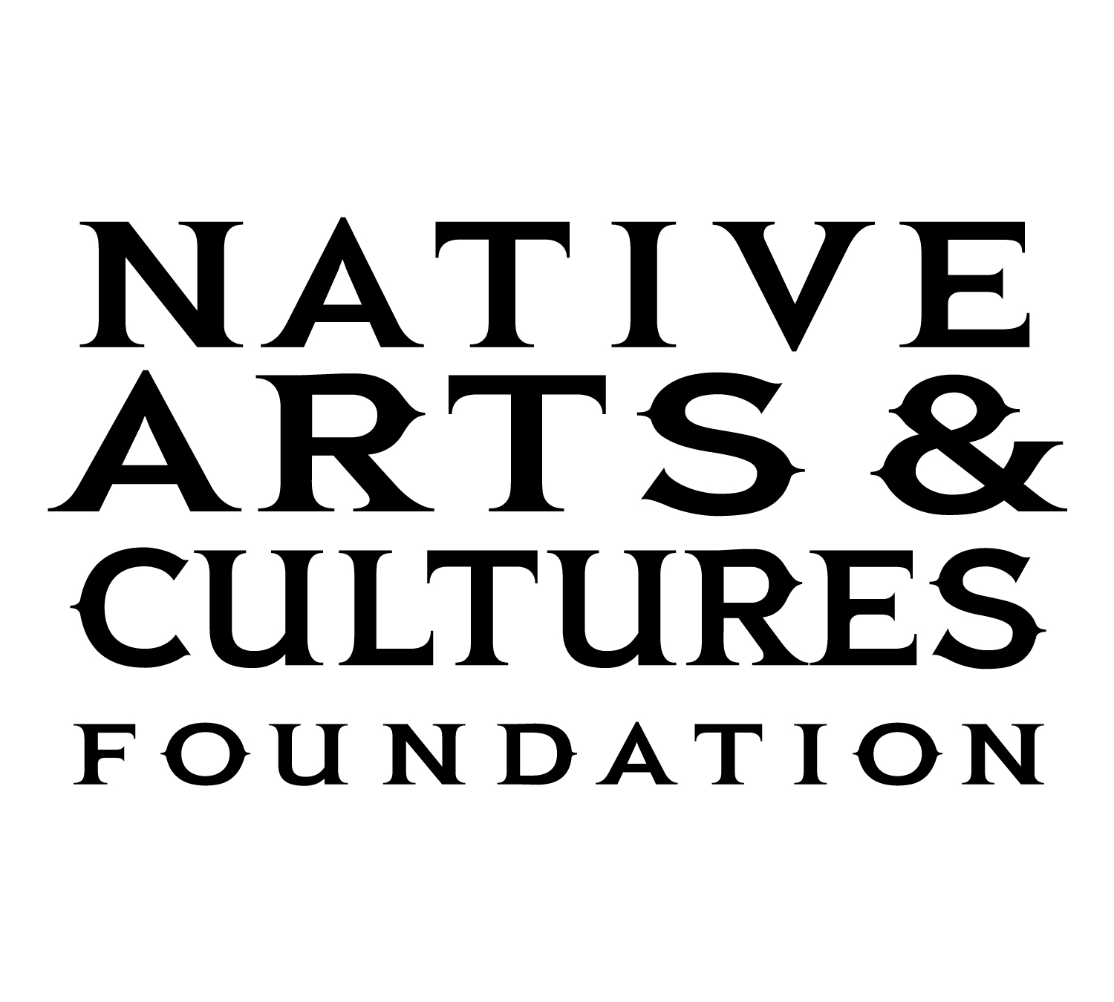

Media Contact:
Barbara Soule
(360) 334-7263
barbara@nativeartsandcultures.org

NATIVE ARTS AND CULTURES FOUNDATION ANNOUNCES
NEW SHIFT PROGRAM AWARDEES FOR 2021

PORTLAND, September 30, 2021 – The Native Arts and Cultures Foundation (NACF) is pleased to announce the first cohort of the SHIFT – Transformative Change and Indigenous Arts program awardees. Following a national open call for American Indian, Alaska Native and Native Hawaiian artists, applications were reviewed by a panel of arts professionals in multiple areas of expertise. Fifteen projects were selected to receive a $100,000 two-year award designed to support artists and community projects responding to social, environmental and economic justice issues to draw increased attention to Native communities.

The SHIFT – Transformative Change and Indigenous Arts program provides multi-year services for Native artists and cultural practitioners to work on expansive projects for community engagement and presentation in collaboration with partner organizations. “Addressing a collective sense of urgency in these times, these SHIFT projects elevate Indigenous lifeways in empowering communities and providing platforms for critical conversations about the state of the world,” says Reuben Roqueñi, Director of Transformative Change Programs.

Selected artists for the SHIFT 2021 (listed by focus area):

HEALING AND COMMUNITY
- Larissa FastHorse (Sicangu Lakota Nation) in partnership with Cornerstone Theater Company. FastHorse’s D/N/Lakota Project is a socially engaged performance project that combines participatory research with theater-making, inviting community participants to share personal stories and civic and social concerns.
- Rosy Simas (Seneca, Heron Clan) in partnership with Weisman Art Museum. Simas’ project she who lives on the road to war is an immersive installation and performance project responding to the loss of hope and life our communities have experienced during the dual pandemics of systemic racism and COVID-19.

ENVIRONMENTAL JUSTICE
- Anna Hoover (Unangax̂ [Aleut]) in partnership with Native Peoples Action Community Fund. Hoover’s Voices of the Land project is an Indigenous justice documentary film grounded in place, culture, and Alaska Native ways of life.
- Will Wilson (Citizen of the Navajo Nation) in partnership with Diné College. Wilson’s project Reframing Indigenous Remediation: Uranium on Dinétah will address the legacy of uranium extraction and processing on the Navajo Nation.

NARRATIVE CHANGE
- Drew Kahuʻāina Broderick (Kanaka ʻŌiwi) in partnership with Pu’uhonua Society. Broderick’s project ʻAi Pōhaku, Stone Eaters is a group exhibition centered on an intergenerational cohort of contemporary Native Hawaiian artists addressing complex historical and present-day issues of Native Hawaiian self-determination.
- Emily Johnson (Yup’ik) in partnership with New York Live Arts. Johnson’s project Being Future Being is a dance performance/process which asks audiences to consider stories with the power to sustain a world that must begin again.
- Moses Goods (Kānaka Maoli) in partnership with Honolulu Theatre for Youth. Goods’ project KII A LOAA is a site-specific experience to reclaim crucial spaces in Honolulu by creating “digital monuments.”
- New Red Order (artist collective) in partnership with Creative Time. New Red Order’s project Give It Back is the enactment and long-term development of an Indigenous-led movement and community space to repatriate land back to Indigenous peoples in New York City and worldwide.
- Postcommodity (artist collective) in partnership with the University of Arkansas, School of Art. Postcommodity’s project Cosmovisión is a musical instrument performed by four people simultaneously using joystick controllers, interactive video, and sound to co-determine relationships between land, community, and worldview.

CULTURAL PRESERVATION
- Ciara Lacy (Kanaka Maoli) in partnership with Pacific Islanders in Communications. Lacy’s project The Queen’s Flowers is a whimsical, animated short film designed to give Indigenous Hawaiian children an entertaining and empowering way to access their history.
- Lily Hope (Tlingit) in partnership with Goldbelt Heritage Foundation. Hope’s project Protecting the Material Sovereignty of Our Indigenous Homelands will provide mentorship to multiple weavers through intergenerational research, documentation, and advocacy directly addressing indigenous land sovereignty.
- Raiatea Helm (Kanaka Maoli) in partnership with Kealakai Center for Pacific Strings. Helm’s project A Legacy of Hawaiian Song and String will explore the music of late 19th-century composer and musical prodigy Mekia Kealakai while spreading the message of the colonial theft of the Hawaiian Kingdom.
- Sabra Kauka (Native Hawaiian) in partnership with Garden Island Arts Council and National Tropical Botanical Garden. Kauka’s project E Ho’omau (to perpetuate) will focus on the art of Kapa and botanical dyes by designing and creating costumes for 20 women and ten men in a halau (hula school) for their participation in Merrie Monarch, the world’s premier hula festival.

MENTORING + EDUCATION
- Raven Chacon (Diné) + Michael Begay (Tribal Member of the Diné Nation) in partnership with the Grand Canyon Music Festival. Chacon and Begay will mentor youth in the Native American Composer Apprentice Project to support, promote, and amplify young creative voices on the Navajo and Hopi Nations.
- Stephen Qacung Blanchett (Yup’ik) in partnership with Old Harbor Alliance. Blanchett’s project Cuumillat’stun - Like Our Ancestors will develop a series of workshops to strengthen Sugpiaq/Alutiiq drumming and dancing, fostering the development of a new generation of composers and choreographers within the seven communities that reside on Kodiak Island.

Native Arts & Cultures Foundation is grateful for the generosity of our growing circle of supporters. Thank you to the following in support of our national programs this year: The Collins Foundation, Cotyledon Fund, Ford Foundation, Leon Polk Smith Foundation, MacKenzie Scott and Dan Jewett, NoVo Foundation, Open Society Foundation, Rainbow Pineapple Foundation, and Rincon Band of Luiseño Indians.

About the Native Arts and Cultures Foundation
The Native Arts and Cultures Foundation’s mission is to advance equity and cultural knowledge, focusing on the power of arts and collaboration to strengthen Native communities and promote positive social change with American Indian, Native Hawaiian, and Alaska Native peoples in the United States. The Foundation has supported over 300 artists and arts organizations in 34 states and the District of Columbia. To learn more about the Native Arts and Cultures Foundation, visit www.nativeartsandcultures.org.

