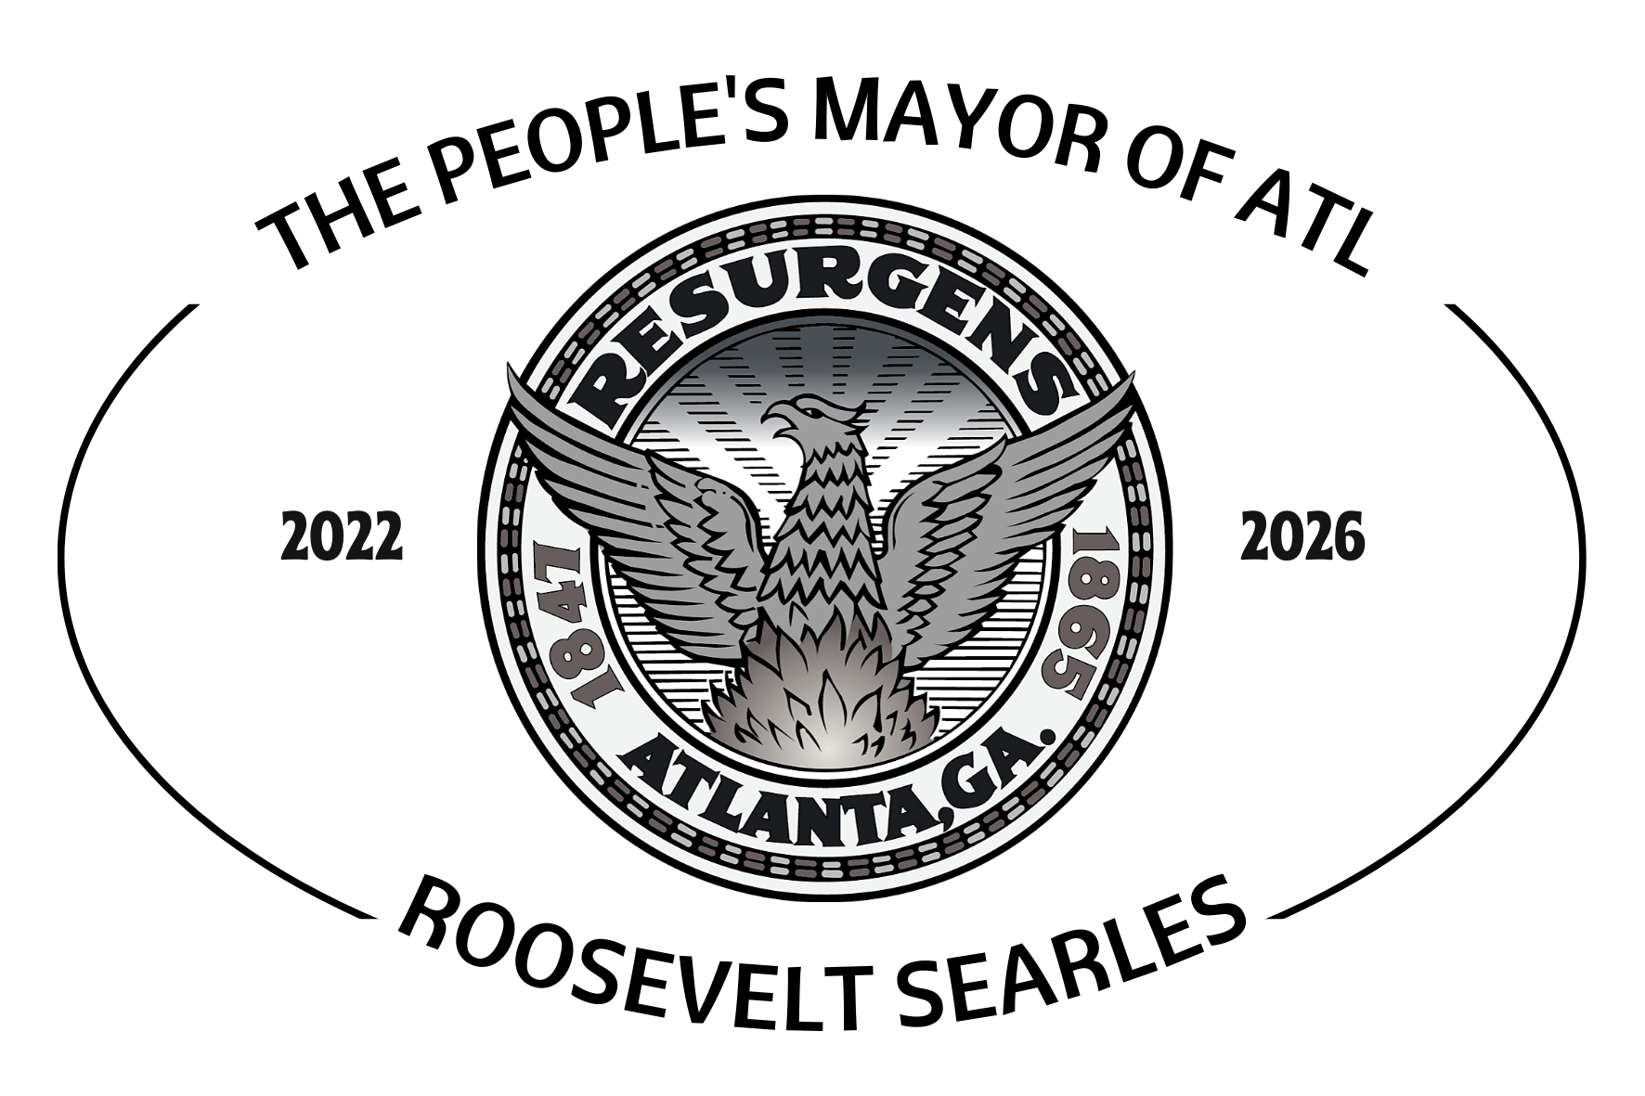

**FOR IMMEDIATE RELEASE**

October 26th, 2021

**Endorsement from ROOSEVELT The People’s Mayor of Atlanta**

Greetings my fellow readers,

It is my pleasure to announce my endorsement for Kirsten Dunn For Mayor of Atlanta. Our leadership for the city will be so impactful and the work to be done is vital! During the last few months running for Mayor I’ve become aware of the fraud and pay to play politics that stain city hall. I have also been led to believe that my life may be in danger should I continue my pursuit as Mayor of Atlanta. With my plans for the unsheltered population, affordable housing, investigations and audits, youth funding and others, this has rattled the nest.

My life's commitment is to the people of my creator. We have been oppressed, murdered and held down for too long. We are confused, scattered and primarily controlled by fear. The systems put in place have been working only to the benefit of those who don’t look like me.

In late 2020 I founded a non-profit, **The National Fresh Start & Assistance Institute**, In March 2021, I released a detailed short book named “**Rebuilding Black Wall Street, The End of Black Oppression**”, and now present day, my team and I are working to create the **Atlanta Freedom Project**.This program will be tendered towards providing resources, trade skills, rehabilitation, business education, and financial training to our youth, veterans, and unsheltered.

The mayor of any city has to be unbiased and a mayor for all its residents. At this time I can honestly say that my heart is presently dedicated to people of color. With that in mind, we must have a mayor who can focus on all races and classes that reside in the city.

I accept the position of Deputy Mayor under the Dunn administration and I look forward to working to unite the greatest city in the NATION!

I will not be dropping out of the race, however the circumstances surrounding my candidacy have changed.

Stay Blessed and Be Safe!

***

Roosevelt Searles III

The People’s Mayor Of Atlanta