Choithrams brings hope to survivors of Sierra Leone explosion

Among the first to respond, Choithrams is providing life-saving medicines and free treatment to victims

- At least 144 dead after oil tanker explodes in Sierra Leone capital Freetown
- UAE sent 16 tonnes of urgent medical aid
- 8 patients being treated at Choithram Memorial Hospital
- Choithrams partnering with Interburns has flown in 2 burn specialists to Freetown to treat victims recuperating in various hospitals
- First Choithrams outlet was established in 1944 in Sierra Leone

25 November 2021, Dubai, UAE: The popular community supermarket brand Choithrams has been among the first to respond to the oil tanker explosion in Sierra Leone that has made global headlines. The ghastly incident took place in the densely populated Wellington suburb in Sierra Leone’s capital Freetown at a busy junction near the Choithram supermarket.
Sierra Leone National Disaster Management Agency (NDMA) confirmed that vehicles collided when an oil tanker was entering a nearby filling station to discharge its fuel. The blaze from the tanker explosion engulfed other vehicles and pedestrians nearby, leaving more than 144 dead and dozens fighting for survival.
The World Health Organization tweeted, “We are working to deploy burnt-patient care experts. We will provide more support as needed, at this terrible time for the people of Sierra Leone.”
Choithrams was amongst the first to bring relief to the victims. According to news agency WAM, the UAE sent an aircraft carrying 16 tonnes of urgent medical aid to Sierra Leone to mitigate the effects of the humanitarian disaster facing the capital Freetown.
Eight patients from the accident site are being treated at Choithram Memorial Hospital in Freetown at zero cost, dozens have been provided first-aid and medicines for free. Choithrams has significant experience in burn treatment at its Hospital and Research Centre in India and through its global partnership with Inerburns, a UK-based charity responsible for developing a comprehensive, integrated approach to quality improvement in burn treatment in many countries across Asia, Africa and the Middle East.
In partnership with Interburns, Choithrams has organized to fly in a specialist burn therapist to Freetown to help assess and provide technical support to the victims. This critical intervention will ensure that patients’ rehabilitation forms part of the overall health sector response strategy from the outset of the emergency. It will also help establish clear rehabilitation care pathway to ensure follow up for patients once they leave acute care indicating any further support needed. The presence of the expert on ground will also ensure alignment with Ministry of Health and key national rehabilitation actors to establish a mid-long-term plan, and sustainability of the rehabilitation response.

UN Secretary-General António Guterres said in a statement issued by his spokesperson, that he was “deeply saddened by the extensive loss of life.” Sierra Leone’s President Julius Maada Bio described the incident as a national tragedy. The President visited Choithram Memorial Hospital to oversee the relief efforts. He saw the victims and engaged with Choithrams management and medical team in charting the way forward and recuperation of patients.
The UAE is building towards the next 50 years on its golden jubilee in 2021, an important part of the strategy will be to consolidate the global footprint of the nation’s humanitarian programs. With its “Full of Goodness” promise, brands like Choithrams are well-positioned to contribute to the national vision given the success of their ongoing projects like the recent intervention in Sierra Leone, as well as global outreach programs over decades.
Choithram International Foundation, the philanthropic arm of Choithrams, works with several local, regional and global entities to foster the Sustainable Development Goals of the United Nations. Through its donorship of international projects in education, healthcare, food security and sustainable practices, the Foundation impacts the lives of more than 50 million people in Africa, Asia and Middle East.

About Choithrams
Choithrams is a successful enterprise with associates in diverse fields including manufacturing, distribution, commodities and retailing. This rich combination brings to the group a huge fund of experience and resources. Choithrams came to the UAE in 1974 and its chain of over 40 supermarkets have made it a household name in the Emirates. The Choithrams outlet was established in 1944 in Sierra Leone.
Follow us on Twitter at @choithramsuae or check our website: www.choithrams.com/en/
About Choithram Memorial Hospital – Sierra Leone
Choithram Memorial Hospital (CMH) of Freetown, capital of the west African nation Sierra Leone, is one of the leading healthcare facilities in the region. Founded in 1997, the multi-specialty hospital is focused on providing relief to patients with a humanitarian outlook. Spread across twenty buildings, CHM is housing critical care units, outpatient wards and operating rooms. CMH regularly provides assisted medical support to patients from vulnerable communities.
For more information, contact - Kirti Malhotra, email: kmalhotra@choithrams.com

Images and Videos for reference
Sierra Leone’s President Julius Maada Bio visiting Choithram Memorial Hospital – full video http://bitly.ws/jzb4

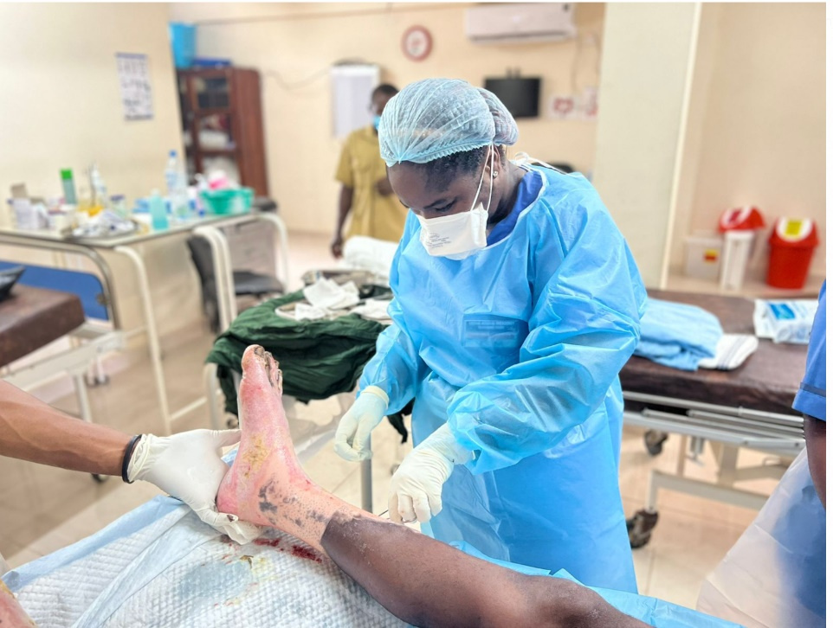

Photo 1, Caption: Many critical patients from the accident site are being treated at Choithram Memorial Hospital in Freetown at zero cost. Pictured here, CMH staff tends to burn victim.
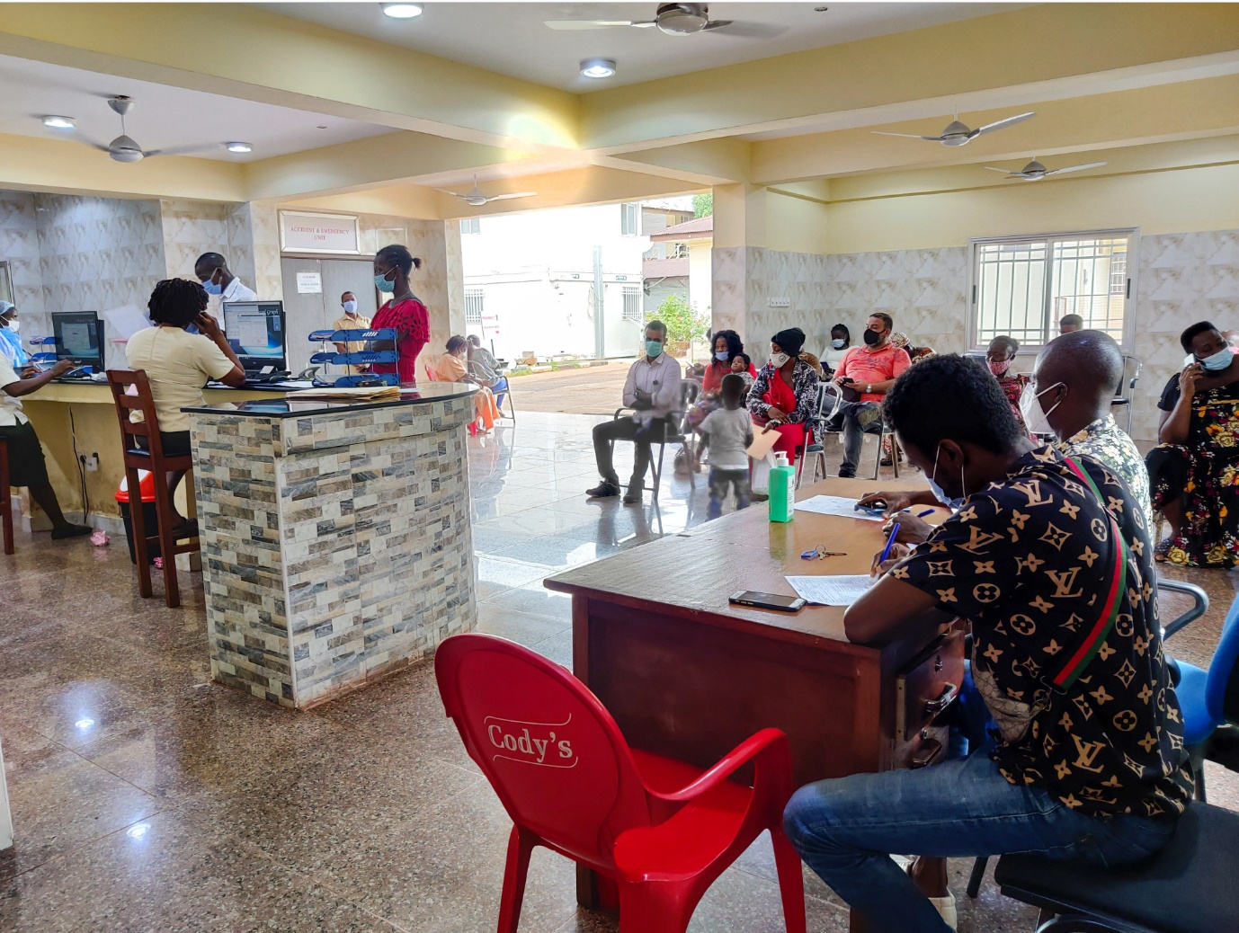

Photo 2, Caption: Dozens of Wellington explosion victims have been provided first-aid at Choithram Memorial Hospital. Many continue to be supported with medicines and check-up for free. Pictured here: patients waiting for treatment at the reception area of CMH.

