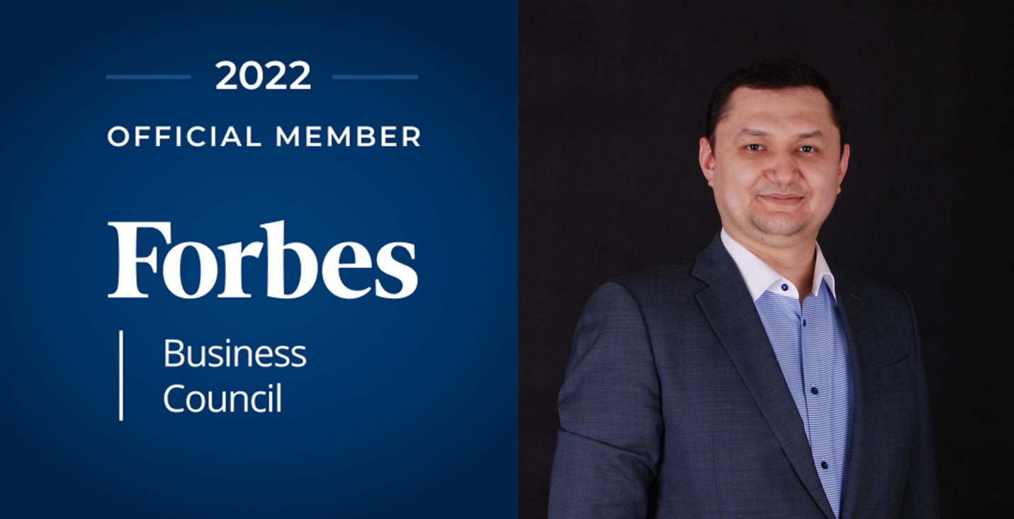

Nodir Turdimatov - Ruzmatov accepted into Forbes Business Council

Forbes Business Council Is an Invitation-Only Community for Successful Business Owners and Leaders

Dallas, January 20, 2022] — Nodir Turdimatov – Ruzmatov, co-founder and CEO of the fast growing technology and knowledge process outsourcing company RevoTech, has been accepted into the Forbes Business Council, the foremost growth and networking organization for successful business owners and leaders worldwide.

Nodir Turdimatov – Ruzmatov was vetted and selected by a review committee based on the depth and diversity of his experience. Criteria for acceptance include a track record of successfully impacting business growth metrics, as well as personal and professional achievements and honors.

“We are honored to welcome Nodir Ruzmatov into the community,” said Scott Gerber, founder of Forbes Councils, the collective that includes Forbes Business Council. “Our mission with Forbes Councils is to bring together proven leaders from every industry, creating a curated, social capital-driven network that helps every member grow professionally and make an even greater impact on the business world.”

As an accepted member of the Council, Nodir has access to a variety of exclusive opportunities designed to help him reach peak professional influence. He will connect and collaborate with other respected local leaders in a private forum and at members-only events. Nodir will also be invited to work with a professional editorial team to share his expert insights in original business articles on Forbes.com, and to contribute to published Q&A panels alongside other experts.

Finally, Nodir will benefit from exclusive access to vetted business service partners, membership-branded marketing collateral, and the high-touch support of the Forbes Councils member concierge team.

“Forbes is a name synonymous with business and leadership, and I am honored to join the group of esteemed business leaders who make up the Forbes Business Council,” said Nodir Ruzmatov, Co-Founder and CEO of RevoTech “I look forward to working with Forbes to ensure that we find opportunities to help further cement the RevoTech’s role in making made-in-Uzbekistan technology companies succeed and lead on a global stage.”

ABOUT FORBES COUNCILS
Forbes Councils is a collective of invitation-only communities created in partnership with Forbes and the expert community builders who founded Young Entrepreneur Council (YEC). In Forbes Councils, exceptional business owners and leaders come together with the people and resources that can help them thrive.

To learn more about Forbes Councils, visit forbescouncils.com.

