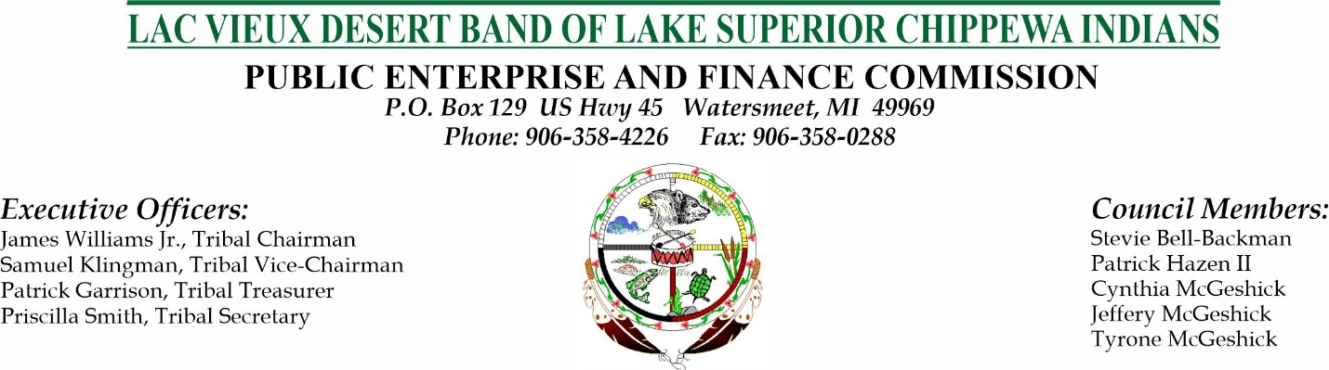
Northern Waters Casino Resort and the Lac Vieux Desert Band of Lake Superior Chippewa Indians to Become the Official Resort-Casino of The Hodag Country Festival

Watersmeet, MI - The Lac Vieux Desert Band of Lake Superior Chippewa Indians today announced a partnership with the Hodag Country Festival. The partnership designates the Tribe’s Northern Waters Casino Resort as a proud sponsor of the festival starting with the 2022 season and the 44th iteration of the fest.

"The Hodag Country Festival is one of the biggest and longest running country festivals in the mid-west if not the nation, its popularity in the Northwoods of Wisconsin and the UP of Michigan is unmatched," said Michael J. Broderick, Northern Waters Casino Resort’s General Manager. "Through this partnership we are thrilled to offer our guests more access to the biggest festival in the region."

"We are pleased to have Northern Waters Casino Resort as an exclusive sponsor and partner of the Hodag” said Gerry Van Harpen, Hodag Country Festival Coordinator. "The Tribe and the casino- resort are dedicated to providing the best entertainment to their customers and guests, and we are sure the festival will be an important part of that premier guest experience."

The Tribe and the Hodag Country Festival celebrated their new partnership in Watersmeet on Friday, February 4th. The private event was attended by members of the Lac Vieux Desert Tribal Council, Northern Waters Casino Resort Executives, and special guests.
“When the Council and I were made aware of the opportunity to renew our relationship with the Hodag Country Festival, we were very excited.” Remarked James Williams Jr. the Lac Vieux Desert Tribal Chairman. “We knew immediately that this was going to be something we wanted to be part of, and we look forward to the mutual successes it will bring.”

The Hodag Country Festival has been proud to host some of the best country music artists since its inception in 1978. In addition, they’ve had a band contest every year since 1981 with talented performers who have earned the title “Wisconsin State Champion Performers”.
The Hodag Country Festival has been featured on TV programs like Discover Wisconsin and ranked among the favorite destinations in the state. This year’s Hodag Country Festival will feature nationally known artists like Sawyer Brown, Jo Dee Messina, Russell Dickerson and the always popular Neal McCoy. More information can be found at www.hodag.com
Northern Waters Casino Resort is located in Watersmeet, Michigan about eight miles north of the Wisconsin-Michigan border in Michigan's Western Upper Peninsula. We are a friendly community surrounded by the Ottawa National Forest and the Sylvania Wilderness Area and are proudly owned and operated by the Lac Vieux Desert Band of Lake Superior Chippewa Indians. We offer casino style gaming with over 500 gaming machines that include the newest themed slot machines in the area. There is a new Pointsbet sports book as well as the new “The Contemporary” Art Gallery for your enjoyment.
The Northern Waters Casino Resort offers a 132-room hotel, which has whirlpool/fireplace suites, an indoor pool, sauna, and a large whirlpool. We offer live music, a sports bar with food, snack bar, and a challenging eighteen-hole golf course. For more information, kindly visit http://www.northernwaterscasino.com

