FOR IMMEDIATE RELEASE CONTACT: Carrie Livingston
Email: carrie@colinkurtis.com
Phone: 815-519-8302
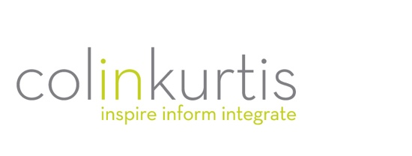
COLINKURTIS ANNOUNCES PARTNERSHIP WITH NATURAL ALTERNATIVES INTERNATIONAL TO SUPPORT STRATEGIC MARKETING EFFORTS

(March 15, 2022) Rockford, IL – ColinKurtis Advertising, a leading food and dietary supplement industry agency specializing in strategic branding and communication solutions, recently announced it has been named the agency of record for Natural Alternatives International North America (NAI) and Natural Alternatives International Europe SA (NAIE). NAI is an international leader in custom contract nutritional supplement manufacturing, helping customers deliver the highest quality dietary supplements through custom formulation assistance, stringent quality assurance programs, innovative packaging solutions and in-house stability testing.
“We are honored NAI selected ColinKurtis as their marketing partner for their North America and European divisions,” said Colin Kampmier, President, ColinKurtis Advertising. “Our goal is to expand awareness of NAI’s capabilities, driving engagement and new opportunities for NAI teams within each region. NAI’s business is founded on transparency and trust—exactly what we believe in at ColinKurtis. We couldn’t be more thrilled to collaborate with such a gold standard of a brand!”
Renee Michaelson, Director of Global Marketing, NAI said, “Our team is excited to have ColinKurtis work as an extension of our marketing team for NAI’s North America and European divisions. CK has proven to be an ideal partner for us, providing exceptional marketing for some of our other brands such as SR CarnoSyn® Health & Wellness. Their desire to understand our company’s marketing needs is second-to-none and we look forward to the results of these collaborative efforts as we shape the future of NAI NA and NAIE.”
ColinKurtis developed a strategic plan to support NAI through a wide range of marketing services designed to build awareness and brand preference, while driving engagement and traffic to the website’s lead generation funnels. Campaign elements include trade media campaigns within North America, Europe and Asia, trade show booth design, social media and PR campaigns, and additional digital tools the sales teams can use along the customer journey.

NAI manufactures nutritional supplements for the international market with facilities in the U.S. and Europe. They deliver the highest quality and most effective supplements available on the market through their investment in state-of-the-art manufacturing facilities and hold some of the industry’s most stringent certifications, including the Therapeutic Goods Administration of Australia (TGA) and the Good Manufacturing Practices (GMP) standard set forth by the U.S. Food and Drug Administration. NAI recently became the first company to meet new safety and benchmarking standards created by the Supplement Safety & Compliance Initiative (SSCI).

For more information on ColinKurtis or to be inspired by some of the agency’s work, please visit http://www.colinkurtis.com.
###

About ColinKurtis Advertising
ColinKurtis Advertising, a Rockford, Illinois-based company, is a full-service advertising and design firm. The agency strives to provide both business-to-business and business-to-consumer clients with strategic marketing solutions delivered through solid creative direction and concise communication messaging.

